Preface

This is a thesis written by Jesse Spiessens as a part of a Bachelor study in Embedded ICT at Thomas More – De Nayer. The project was one proposed by FH Kiel as part of an Erasmus exchange. The exchange lasted from March 2018 until June 2018.

I would like to thank my supervisors for their guidance through the project and Erasmus administration.

Obviously a big thanks goes out to my parents, funding my education and this Erasmus trip.

I am also very grateful for the friends I met on Erasmus and at home, keeping me sane throughout this endeavour and reading over this Thesis.

Abstract

This document describes the development of a device which takes the output of an instrument or a microphone and modifies that output. The device is known as an audio effects pedal or multi-effects pedal.

The goals with this pedal is to make it small while still providing a flexible platform. Flexibility here is mainly given by the touchscreen, onboard Wi-Fi and the rather powerful 400 MHz STM32H7 microcontroller. The touchscreen provides a local interface which can be used in combination with rotary encoders to add, remove and edit effects.  
Using Wi-Fi, one can do the same things over a web interface.

For easier control using your foot, dedicated switches and status LEDs are fitted.

As a later add-on, users could be able to compose their own effects. This could be accomplished by the use of plug-ins.

Table of Contents

Introduction 6

1 Hardware 7

1.1 Compute board 10

1.1.1 Requirements 10

1.1.1.1 Microcontroller 10

1.1.1.2 Memory 10

1.1.1.3 CODEC 10

1.1.2 Supplies 11

1.1.2.1 Power switching 12

1.1.2.2 Digital supply 13

1.1.2.3 Analog supply 13

1.1.2.4 Backlight supply 14

1.1.3 Microcontroller 15

1.1.4 RAM 15

1.1.5 CODEC 16

1.1.6 Screen 16

1.1.7 USB 17

1.1.8 SD Card 17

1.1.9 EMI 18

1.1.9.1 Electromagnetic shielding 18

1.1.9.2 Ringing 18

1.1.10 Signal integrity 19

1.1.11 ESD 20

1.1.12 Test points 20

1.1.13 Datasheet 20

1.2 I/O board 21

1.2.1 Research 22

1.2.1.1 Component placement 22

1.2.1.2 Power and ground routing 22

1.2.1.3 Decoupling 23

1.2.1.4 Capacitors 23

1.2.1.5 Resistors 24

1.2.1.6 Potentiometers 24

1.2.1.7 Op-amps 24

1.2.2 Supplies 25

1.2.2.1 Auxiliary power input 25

1.2.2.2 Battery input 26

1.2.2.3 Battery charging 27

1.2.2.4 Battery boost 27

1.2.2.5 Digital supply 28

1.2.2.6 Biasing 28

1.2.2.7 Phantom power 29

1.2.3 Pre-amp 30

1.2.4 Auxiliary input 31

1.2.5 Output 32

1.2.6 Headphone output 33

1.2.7 Rotary encoders and switches 33

1.2.8 ESP32 34

1.3 Design 35

2 Software 36

2.1 Flexible Memory Controller 36

2.1.1 Configuration 36

2.1.2 Initialization 36

2.1.3 Data transfer 36

2.2 SPI 37

2.2.1 Configuration 37

2.2.2 CODEC initialization 37

2.3 SAI 38

2.3.1 Configuration 38

2.3.2 Utilization 39

2.4 Program structure 40

2.4.1 Startup and audio 40

3 Conclusion 41

3.1 Compute board 41

3.1.1 Possibilities for improvement 41

3.1.2 Flaws 41

3.2 I/O board 41

3.2.1 Possibilities for improvement 41

3.2.2 Flaws 41

3.3 Software 42

List of figures 43

List of acronyms 44

List of citations 45

Attachements 46

Introduction

Looking at similar products on the market, it places itself in the top of mid-range products. It’s a good compromise between form-factor and features.

In terms of features, it is comparable to a Line 6 Helix LT, while its size is more similar to a Zoom G1on. Pricing of this device would be in the €300 - €400 range.

This work covers the hardware part from requirements to implementation. It’ll also go over the software responsible for basic operation.

A conclusion presenting the current state of development can be found at the end of this paper.

# Hardware

As a design requirement was reusability and low cost, a dual board construction seemed appropriate. One digital board, used mostly for signal processing and communication.  
Another for analog conditioning and enabling Wi-Fi.

The digital board is a 4-layer PCB which contains the microcontroller, memory, analog to digital and digital to analog converters, power switching and regulation circuitry and a display connector. Also provided but outside the scope of this thesis is a USB and SD card interface. This board, nicknamed “Cap’n MaGee”, will from here on out be referenced as the compute board. This board is responsible for data processing.

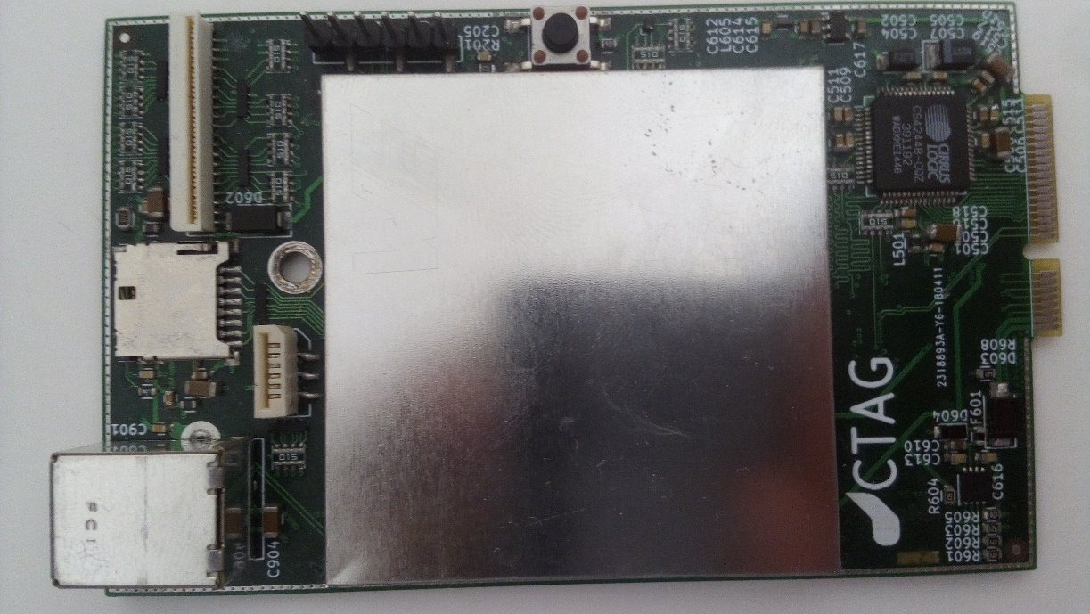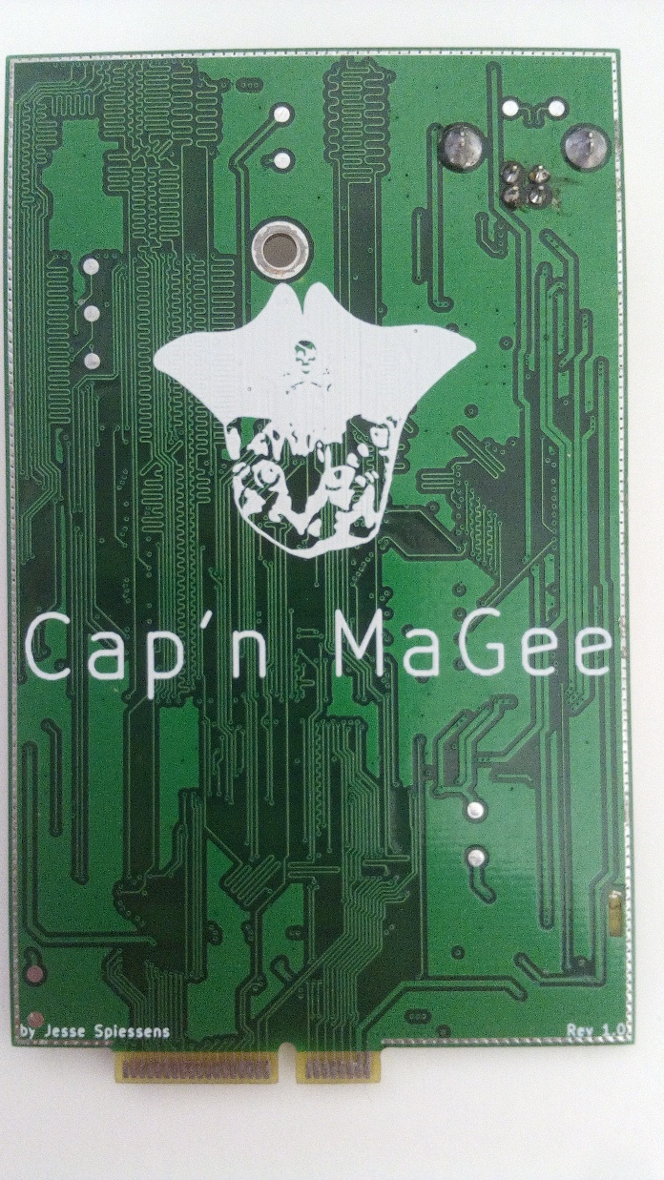

Figure 1: Compute board front and back

The other board, which is a 2-layer design, features audio in- and output connectors, preamps and buffers, voltage regulation, battery management, Wi-Fi and the user I/O. This board, nicknamed “Aellö”, will from here on out be referenced as the I/O board. This board is responsible for conditioning of analog input signals, battery management and makes the board mountable in a case.

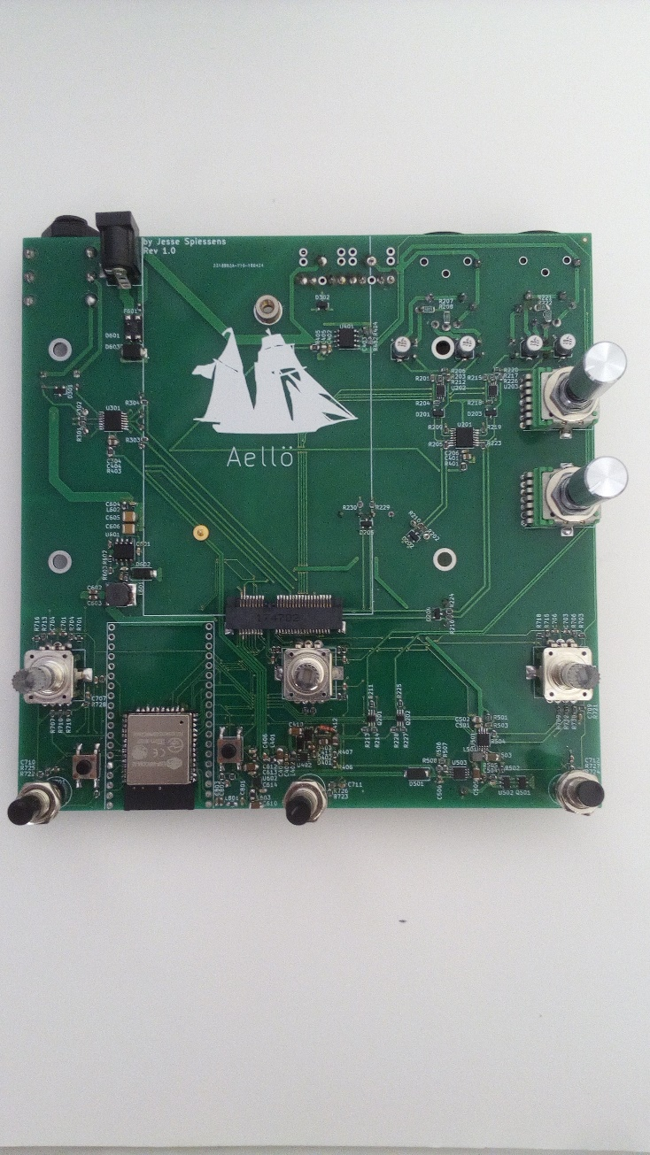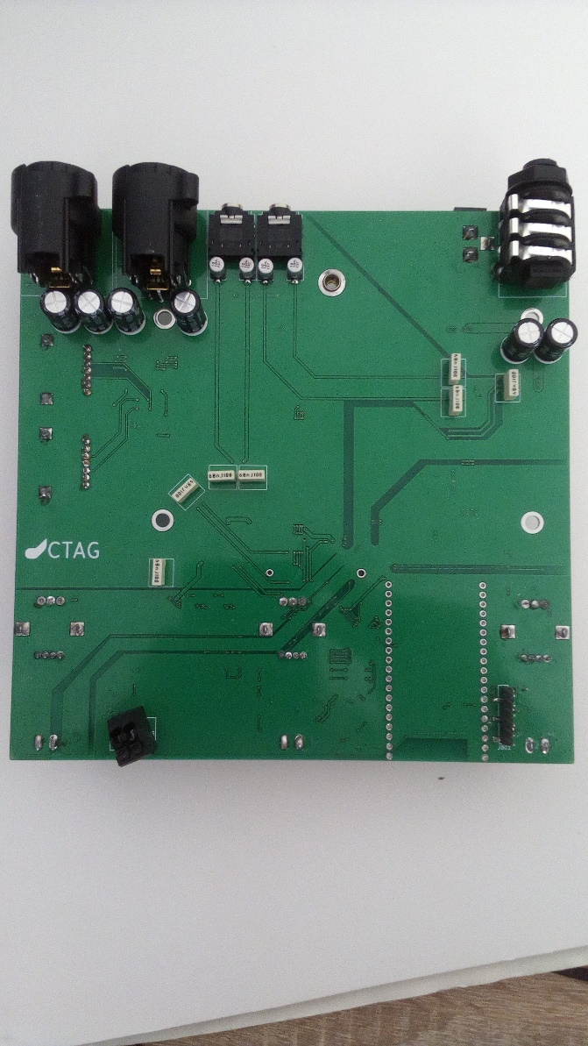

Figure 2: I/O board front and back

The interface between the two boards is accomplished via a Mini PCI-e connector located on the I/O board. The compute board has fingers to match the connector. To fit the connector, the compute board needs to be 1mm thick. It is recommended to have a 45° chamfered border to extend longevity of the connector and matching PCB.

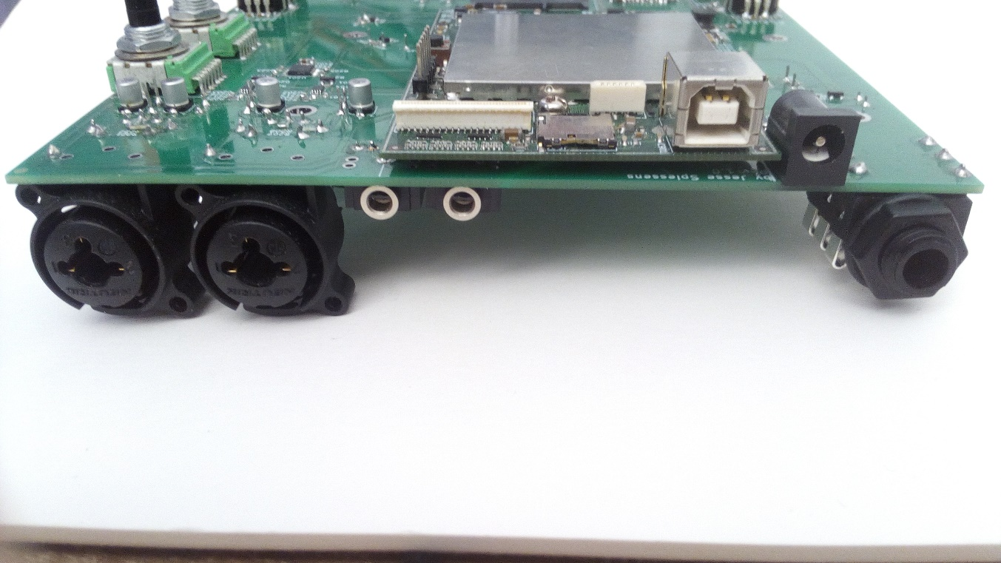

Figure 3: In- and output connectors

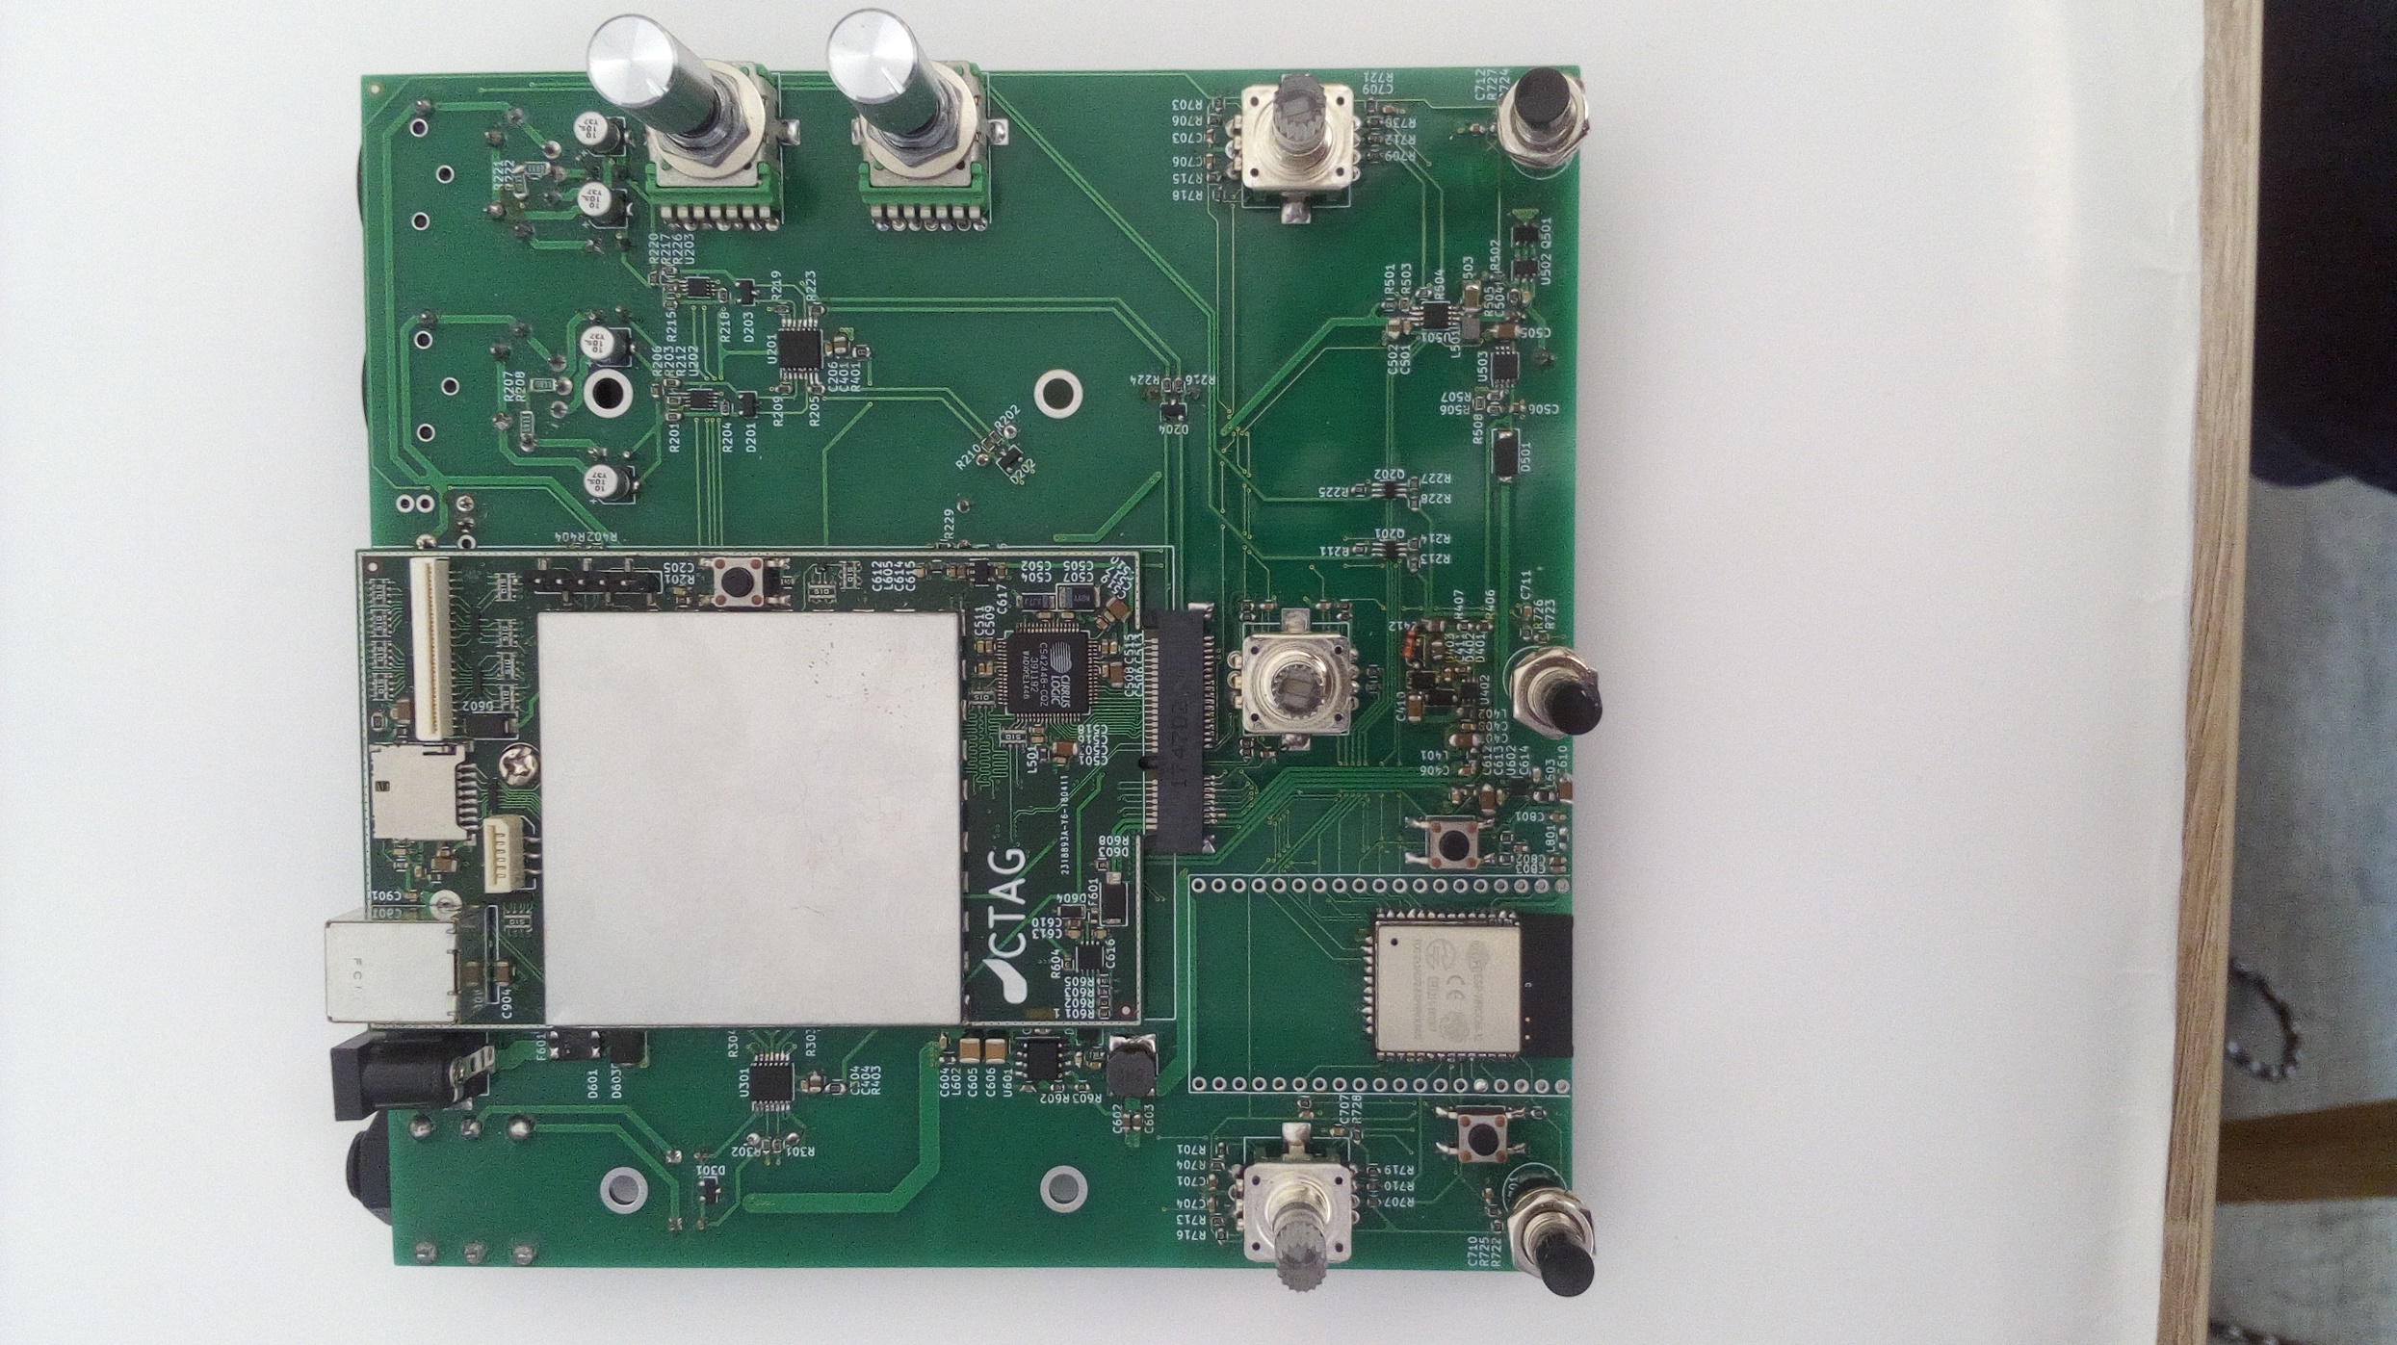

Figure 4: I/O board with the compute board plugged-in

## Compute board

### Requirements

#### Microcontroller

As mentioned in the introduction, the aim of this work is to use the STM32H7 because of its high performance and variety of features. To find the most suitable variant, attention was put on pin count, solderability and availability. Given all the peripherals on the board, a minimum of 125 I/O pins was settled upon. This, together with solderability, led us to either the LQFP176 or LQFP208 package. Because of availability, the STM32H743 in a LQFP176 package was opted for.

#### Memory

The requirements for certain audio effects dictate a large amount of memory, e.g. for delay effects. Thus 32 Mbytes of Dynamic RAM is used. It offers good compromise in terms of cost and size.

#### CODEC

As mentioned before, the parts to convert analog signals into digital ones and digital into analog ones will be on the compute board. To lower the cost and space taken up on the PCB, an IC which contains both the ADCs and DACs is ideal. Several manufacturers make these. A Cirrus Logic one was chosen because of the brand its popularity. Their CS42448 stood out most, with its total of 6 analog inputs and 8 analog outputs. This amount of analog I/O helps contribute to the reusability factor of the board.

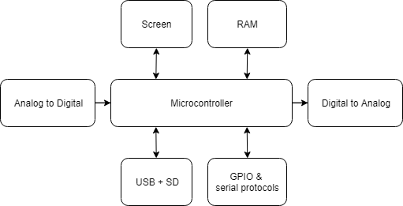

Figure 5: Compute board block diagram

### Supplies

The compute board can be powered off of 3 different sources. USB, Vaux and Vbat. USB power, also named Vbus, comes from the onboard USB connector. Vaux and Vbat go over the mini PCI-e connector. The Vaux input is a 5 V regulated input coming from an external connector on the I/O board. Vbat is provided by an internal battery, which has been boosted up to 5 V.

|  |  |  |  |
| --- | --- | --- | --- |
|  | **Vaux** | **Vbat** | **Vbus** |
| **Connector** | Mini PCI-e | Mini PCI-e | USB |
| **Typical voltage** | +5 V | | |
| **Maximum voltage** | +5.5 V | | |
| **Maximum current** | 1.25 A | | |

Table 1: Compute board power inputs

#### Power switching

When multiple power sources are provided, the board will automatically switch between them. The board has been designed so that Vaux gets priority, then USB and then Vbat. The hardware responsible for this is a power mux, more specifically the TPS2113A. When Vaux is applied, it shuts down the TPS2113A, leaving the output at a floating state. Power to the system is then provided through the diode, D603.

When Vbus and Vbat are present, USB will be chosen as the power source by the TPS2113A. This is because the IC’s Vsns pin is held high by Vbus. This in turn selects IN1 as the power source, connecting it to the OUT pin.

The 12 k pull-down ensures that Vsns will go low as the USB disconnects. When Vsns is low, the TPS2113A will choose whichever power source is higher in voltage. This can only occur when Vbat is present. Therefor IN2 will be chosen and Vbat will be connected to the OUT pin.

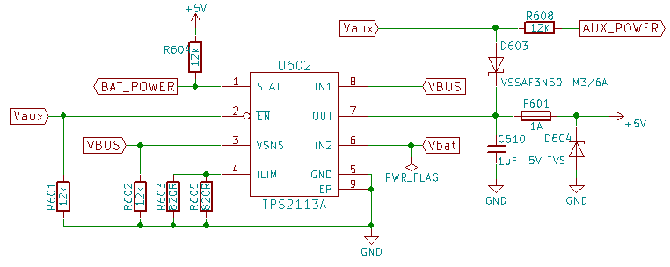Figure 6: Power MUX schematic

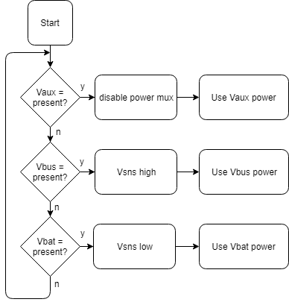

Figure 7: Power MUX flowchart

#### Digital supply

Powering all digital components is the MIC23050. This buck converter steps down the 5 V input to the required 3.3 V. Due to its high switching frequency of 4 MHz, the inductor and input output capacitors can be of a low value. This reduces the footprint required on the board.

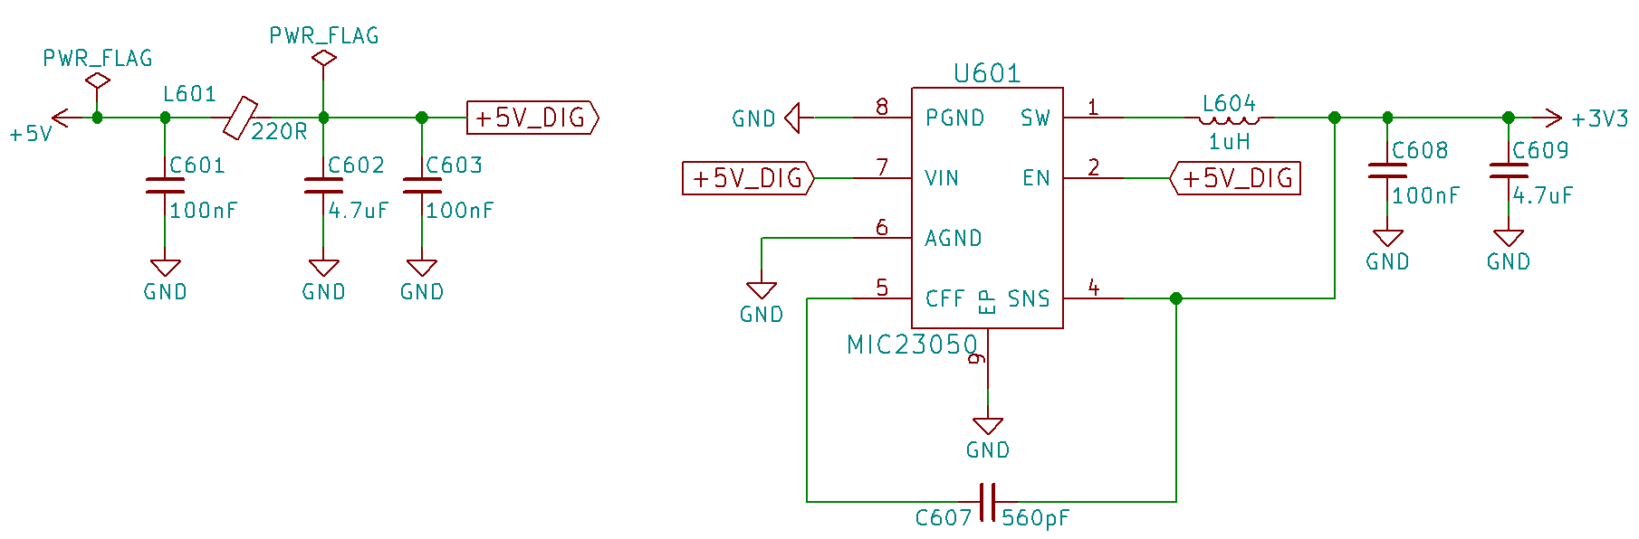

Figure 8: Digital supply schematic

#### Analog supply

The analog supply, providing power to the CODEC’s ADCs[1]and DACs[2], is an ADP150. This LDO[3] was chosen because of its low output noise and high power supply rejection. This means that the IC filters out noise coming from the input while not introducing much noise itself. As noise rejection goes down with increased frequency, an input filter composing of a ferrite bead, L605, and some capacitors is put in front of the input. This filter will give another 48 dB of noise rejection at 1 MHz, increasing with frequency. Although the noise falls far outside the 1st Nyquist band[4], it can still introduce audible artefacts. This is due to aliasing. This is the result of high frequency being seen as lower frequency noise. As an example, the CODEC on this board running at 96 kHz couldn’t know the difference between noise at 4 kHz or at 1.06 MHz.

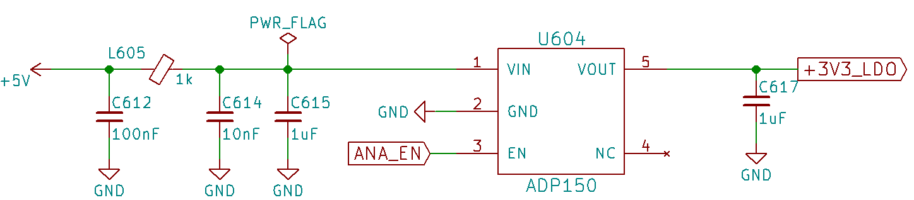

Figure 9: Analog supply schematic

#### Backlight supply

The screen intended to use with this board has a backlight which requires 19.2 V to reach its nominal 60mA. To reach this sort of voltage, a boost converter is used. As dimming the screen is a given feature these days, we went with the TPS61170. This converter has a reference which can be adjusted by programming, or using PWM[5] on the CTRL pin. In order to dim the screen linearly, the feedback pin gets the voltage from a low side current shunt, thus converting the IC in a constant current regulator.

However when a load with an impedance higher than 610 ohms would be connected across the TFT_LED+ and TFT_LED- terminals, the output would exceed its maximum voltage of 38V. To prevent this, a Zener has been fitted to keep the output voltage bellow 22V.

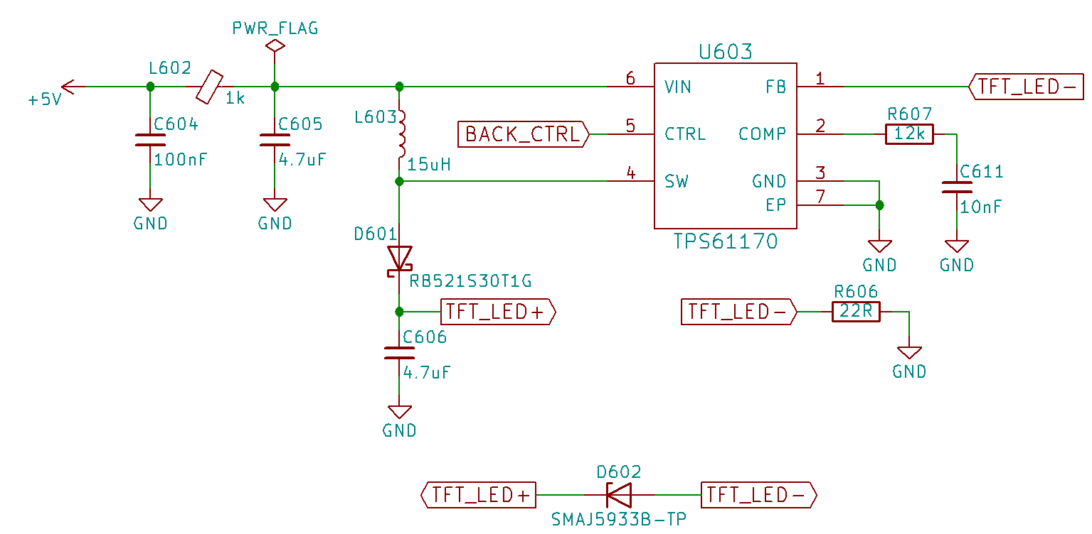

Figure 10: Backlight supply schematic

### D:\Bureaublad\School\Fase 3\Bachelor\Thesis\Report\Figures\Pictures\MCU.jpgMicrocontroller

Figure 11: MCU

The STM32H743II chosen has an 32-bit Arm® Cortex®-M7 core running at frequencies up to 400 MHz. It features a double-precision FPU[6], L1 cache, 2 Mbyte of flash and 1 Mbyte of RAM.

Peripherals used for this project are the LCD-TFT controller, Flexible Memory Controller, the Serial Audio Interface, SPI[7], I2C[8] and UART[9]. Other routed out interfaces include the USB High-Speed capable ULPI and SDMMC for SD cards.

The board also has 2 crystals to be used by the microcontroller. 1 high speed 16 MHz crystal and one low speed 32.768 kHz.

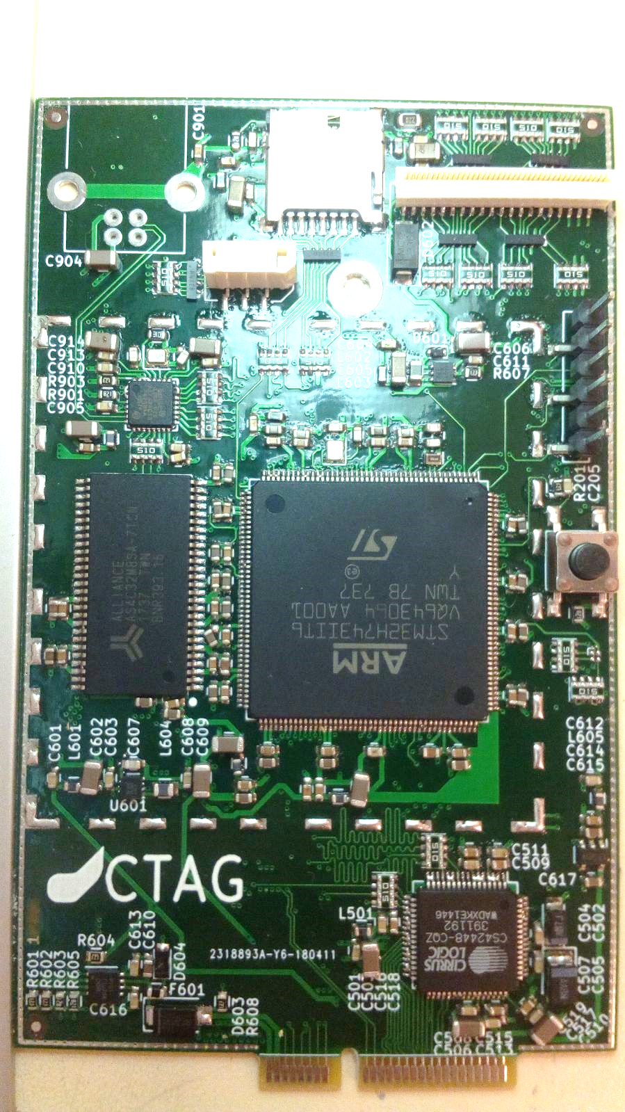

Figure 12: RAM

### RAM

The ASC32M8SA-7TCN is the device giving the 32 Mbyte of SDRAM. Those 32 Mbytes are divided into 4 banks of 8 Mbytes.   
The SDRAM is capable of speeds up to 143 MHz, however, this is limited to 100 MHz at the controller side by the FMC peripheral.

Communication between the FMC and the RAM is done over a parallel interface.   
This consists of CLK, 13 address lines, 8 data lines, chip, clock and write select enable and row and column strobe, as well as 2 pins for bank selection.

### CODEC

The CS42448 is a 6 in, 8 out CODEC capable of sample rates up to 192 kHz in a 24 bit format. With its THD+N[10] of -98 dB in differential mode, its effective number of bits is 16 bit. This makes the board suitable for a wide range of applications.

The CODEC can be configured via an SPI or I2C interface. Using this, things like protocol, volume and input mode can be changed.

Samples are send over the Serial Audio Interface. This can be done using several protocols, however, TDM is recommended as this is the only one to gives access to all channels.

As the CODEC’s analog supply is 3.3 V, the full scale input voltage lies between 1.75 and 1.95 V single-ended, and double that for differential inputs. Exceeding this will clip the digital output of the ADC. Harm to the IC will only occur when exceeding the absolute maximum ratings.

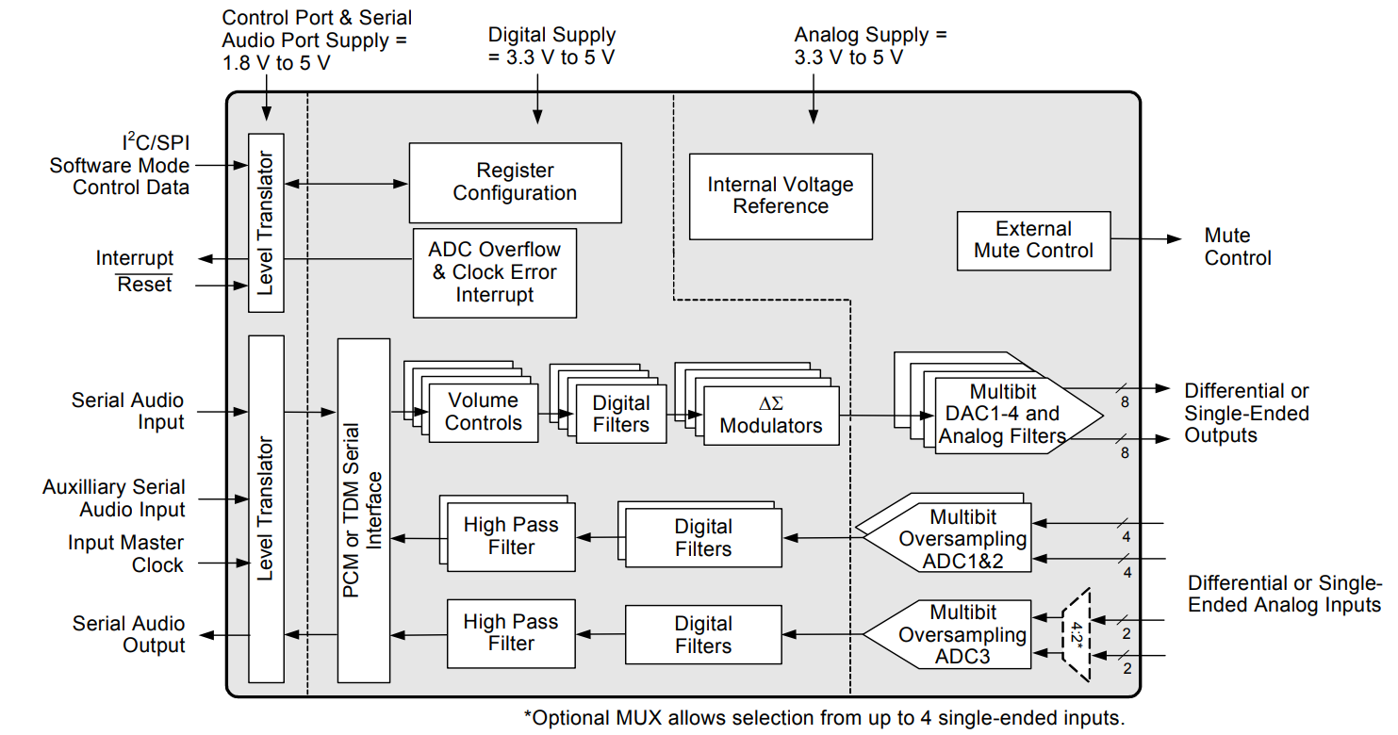

Figure 13: CS42448 block diagram

### Screen

The board is designed to drive screens using the 24 bit RGB interface. More specifically the 5 inch NHD-5.0-8004800TF-ATXL#-CTP. Its resolution is 800 by 480 pixels and features a capacitive touch panel with multi-touch and gesture inputs.

Driving the display is done with the LCD-TFT peripheral. It’s connected with 24 data lines, a clock input, line and frame synchronization signals and a data enable signal. They connect using a 40 pin FFC[11] connector with a 0.5 mm pitch.

The touch panel with its integrated controller communicates to the microcontroller making use of the I2C bus. A dedicated pin for interrupts is also present. This allows the touch panel to wake the microcontroller in the occurrence of an event. Connection of the touch panel and microcontroller are done over a separate connector. This connector is a 6 pin FFC with a 1 mm pitch.

### USB

The STM32H743 has 2 internal USB transceivers. These transceiver are only capable of Full-Speed USB. As the goal was to get Hi-Speed USB on this board, a Hi-Speed capable USB PHY[12] was added. The USB3300 from Microchip was chosen.

The PHY connects to the controller using the industry standard ULPI[13]. This 12 pin interface consists of 8 data pins, 3 control pins and a clock line.

The IC can be configured as a USB host, device or OTG[14] host. As this board has a USB B connector, OTG capability is lost.

### SD Card

The SD card holder is directly connected to the microcontroller via the SDMMC peripheral. The peripheral can reach frequencies up to 100 MHz, allowing for transfer speeds of up to a theoretical 50 Mbyte/s.

The standard SD card interface consists of 4 data lines, a command line and a clock line.

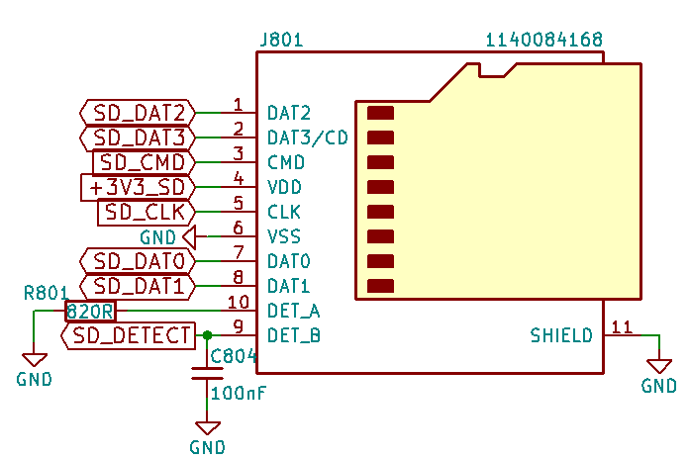

Figure 14: SD card pinout

### EMI[15]

#### Electromagnetic shielding

Because of the high frequency nature of all devices, a collective EMI gasket for all digital devices and switching power supplies was chosen. This helps with radiated emissions.

The Wurth Electronics’ 36103505S SMD frame and its fitting 36003500S are made of tin plated steel. Although the manufacturer does not provide attenuation numbers with these 2 products, their pure tin variants do. Attenuation of 40 dB and higher can be expected between 100 and 400 MHz, with attenuation staying above 30 dB all the way until 3 GHz.

To reduce radiation from ICs to the bottom side of the PCB, a solid ground plane is fitted.

#### Ringing

Ringing on a digital signal is the oscillation that happens after a sharp edge. This is caused by the parasitic inductance of a trace and the parasitic capacitance of the IC’s pin. The parasitic capacitance causes a current spike whenever the signal changes state. This current spike together with the parasitic inductance generates a voltage spike, followed by oscillation.

Because of the parasitic capacitance, ringing gets worse as rise and fall time shortens. Increased ringing also causes increased electromagnetic radiation. As the compute board is full of high frequency components having short rise and fall times, resistors have been placed on several data lines to counteract ringing and thus radiation.

To reduce space and cost, small resistor networks were used. Each element having a resistance of 51 Ohms. This resistance combined with the parasitic capacitance of the trace and the pin of the IC form a low pass filter, attenuating high frequency components in the signal.

Other measures such as reducing parasitic inductance by keeping trace length to a minimum are also taken. Increasing trace width would also have helped with this.

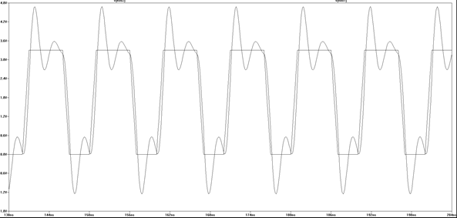

Figure 15: Ringing simulation

Often overlooked but also very important to reduce ringing is a low inductance power path to the IC. This can be accomplished by power and ground planes, wide but short traces and sufficient decoupling, all reducing loop area.

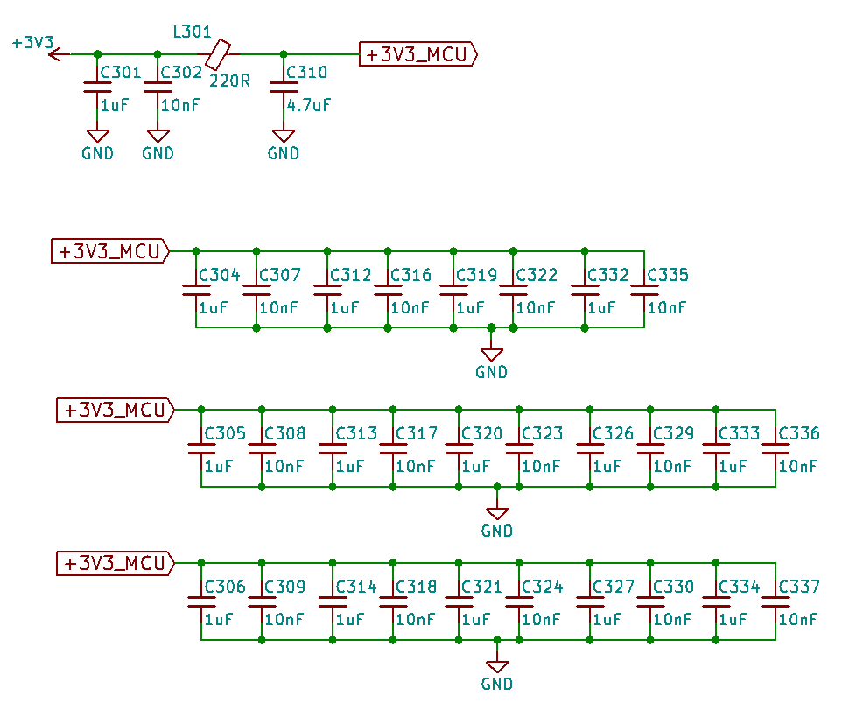

Figure 16: MCU decoupling

### Signal integrity

Because, as previously stated, the board is packed with high frequency signals, it’s good practice to match trace lengths to different ICs. This minimizes skew, ensuring that all data arrives at the IC at the same time and is read correctly. Maximum deviation in matching lies in the tolerances of both communicating devices.

As not to induce too much parasitic inductance, arced lines produces by a length matching tool have a diameter of at least 3 times the track width, preferably 5 times the track width.



Figure 17: Length matching example

### ESD[16]

To protect the board from damage caused by static electricity coming from the outside, TVS[17] arrays have been fitted near the SD card and display connectors. These will limit the voltage going in to the microcontroller. The USB is also ESD protected, implementing its protection in the USB PHY.

### Test points

Various test points are present on the bottom side of the PCB. These, together with the Mini PCI-e connector can be used to program and test the device in a test bench if so desired.

### Datasheet

As this device is meant to be reused in other projects, it seemed wise to construct a datasheet. The sheet consists of the board’s features, pinout, test point and connector locations, physical dimensions and electrical characteristics.

This datasheet together with schematics are attached.

## I/O board

This board is the more application specific board of the two. It serves as the base for the compute board. It also provides the user interface and makes the hardware mountable to a case.

It takes analog inputs coming from an instrument, a microphone or a line level output and conditions it for the compute board. Also the outputs are being conditioned before reaching the appropriate connector.

The device has two differential capable inputs in the form of an XLR/6.3 mm combo jack. Phantom power for these can be toggled individually. The stereo 3.5 mm jack supports line level outputs such as phones, tablets, mp3 players and computers.

The main output is the 6.3 mm TRS jack. It outputs a differential signal and can withstand phantom power. Headphone support is given by another stereo 3.5 mm connector.

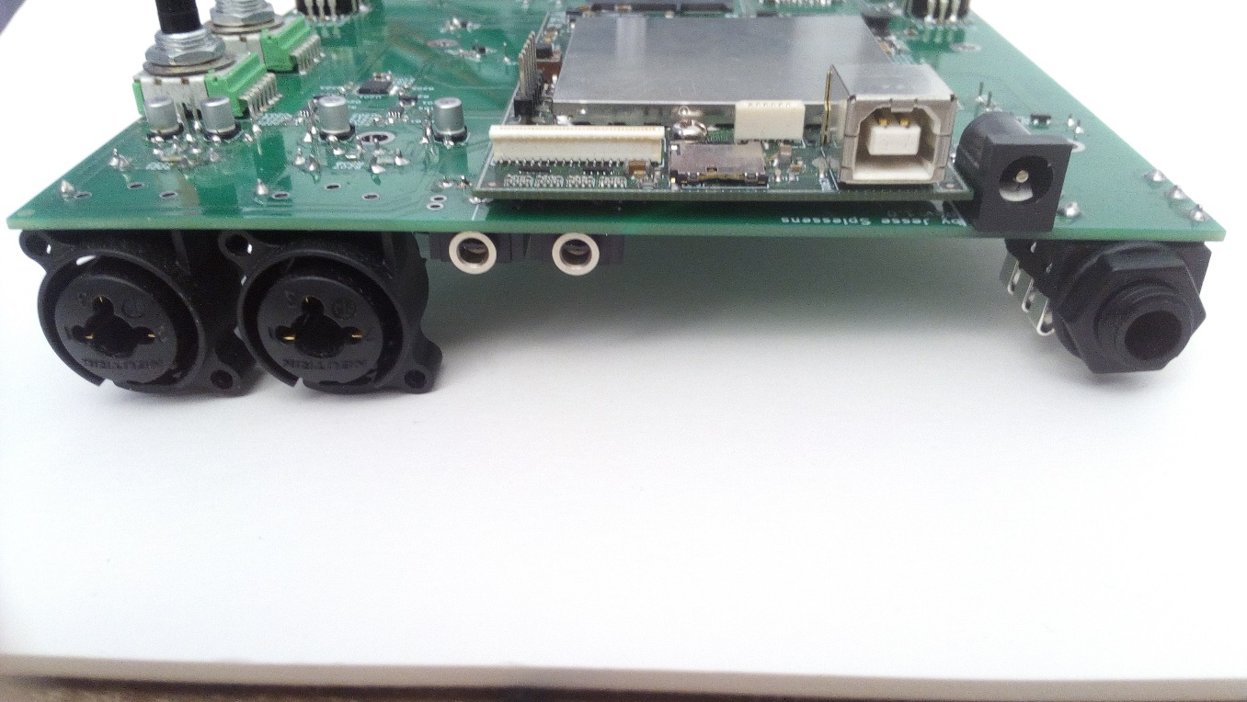

Figure 18: Connectors

In terms of I/O there are 2 potentiometers, 3 rotary encoders and 3 switches. This board also holds the touchscreen.

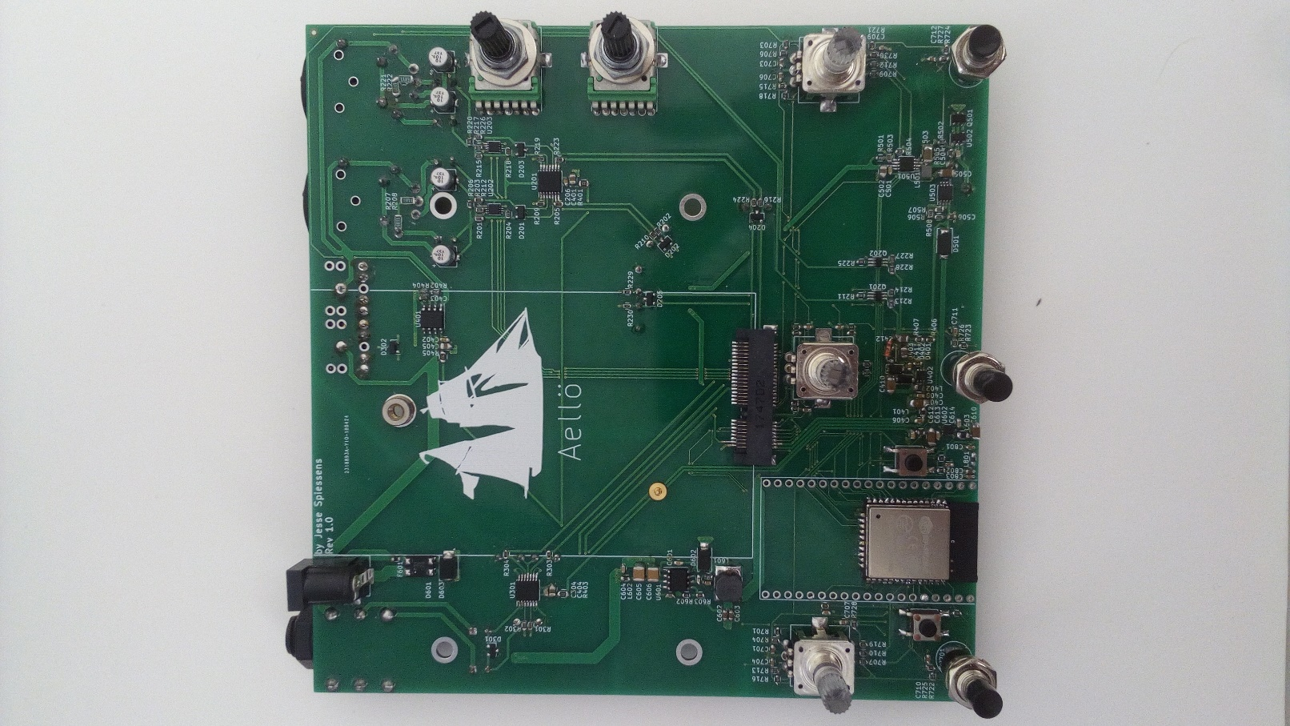

Figure 19: I/O board

### Research

Although not critical for the application, thought has been given to minimizing distortion and noise. This attempted by good PCB design and specific component choice.

#### Component placement

Notable on the board is that analog circuitry can be found in the top half of the board, while the DC/DC converters have been laid out on the bottom half. This can help separate the high frequency current spikes from digital circuitry from analog circuitry. More detail is described in section 1.2.1.2.

#### Power and ground routing

It is generally desirable to have power and ground traces be low impedance, low inductance and high capacitance. Often this is done by a single plane across the whole board. Although not bad, this method could have some drawbacks when components are not placed properly. Current spikes created by digital circuitries could create voltage drops, causing noise in analog circuits.

To prevent this from happening, a hybrid solution consisting of star power distribution and separate analog and digital ground planes in star form have been used.

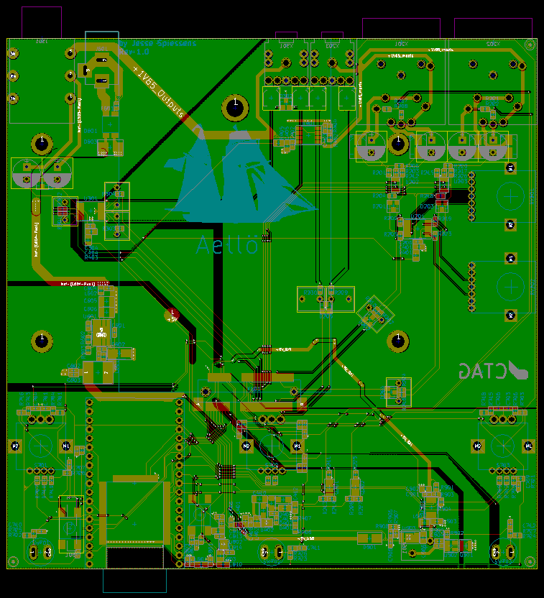

Figure 20: I/O board routing

#### Decoupling

Obviously, decoupling, the placement of capacitors near ICs, helps against noise. They do this by providing a low impedance energy source. This smooths out currents spikes seen by the rest of the system.

#### Capacitors

As there are quite a few different types of capacitors on the market, one might wonder what the difference is in audio applications and which one suits the purpose best. In order to answer this question, defining what makes a high quality system should be done first.

Generally, low noise, together with low distortion looks to be preferred, keeping the input signal clean. Low distortion seems to be related with high linearity.

As ceramics are rather nonlinear, changing in capacitance with frequency and applied voltage, these don’t seem desirable in coupling applications. They are also prone to singing, mechanically resonating/vibrating when a certain frequency is applied.

Common found in low cost audio applications are polarized electrolytic capacitors. Often provided with a DC bias, these capacitors provided distortion figures in the -80 to -90 dB range, making them suitable for many applications, including ours.

Stepping up a notch, bi-polar electrolytic capacitors provide excellent low distortion while keep cost and size low. This time, distortion ranging from -100 all the way till -120 dB, it is a good competitor against the next to be discussed film capacitors.

Film capacitors come in variety of materials. This part will be limited to PET and PP caps. The first one, PET or polyester, is the smaller one of the two. It tends to have slightly higher distortion than the PP or Polypropylene one, but at this point, distortion is so small that it doesn’t matter for our application anymore. Film capacitors also tend to be bulky, making them impractical in some designs.

For this design, the bi-polar electrolytics are used as coupling caps, giving good value for money in a small package. For the low-pass filter bi-polar capacitors are required.  
As 68nF bi-polar electrolytics capacitors are hard to find, film capacitors are used.

|  |  |  |  |
| --- | --- | --- | --- |
|  | **Polarized electrolytic** | **Bi-polar electrolytic** | **PET capacitor** |
| **10µF 10V** | €0,134 | €0,149 | €1,08 |
| **10µF 100V** | €0,089 | €0,25 | €1,08 |
| **68nF** | n/a | n/a | €0,133 |

Table 2: Capacitor prices/10

#### Resistors

Resistors can also introduce noise. Noise greatly varies on the resistive materials used. Carbon and thick-film resistors seem to be introducing more noise than thin-film, metal foil or wirewound resistors.

Thin-film resistors are a great low cost option. Their noise performance generally improves as temperature coefficient and tolerance lowers.

Wirewound resistors are low noise, but tend to be bulky and their inductance often isn’t desirable.

Metal foil resistors stand out, providing lowest noise out of the bunch while having relatively small footprints. The downside of them is their cost.

Thin-film resistors are the better option for this application providing good balance between cost, noise and size.

#### Potentiometers

Single-turn potentiometers exist in a variety of materials. Most popular are the carbon composite ones. This is because of their low cost while still providing reasonable noise figures. However as they wear down, they are prone to turning noise.

Conductive plastic potentiometers counteract this problem, providing long life and low noise. Because of this, these are favored in higher-end audio equipment. These have been chosen as they are a good match for the preamps.

#### Op-amps

In the search for a suitable op-amp, multiple factors come into play. First of all, bandwidth must be high enough to support the gain needed. The gain multiplied by the maximum desired input frequency is the minimum gain-bandwidth needed. As an example, a voltage buffer or unity-gain amplifier in the audible range needs a bandwidth of 20 kHz, as its gain is 0 dB.

For this board, it is also needed to support unity-gain stability.

Third, input noise is desired to be low, especially there where high gain can be present.

Lastly, having a THD+N figure in the datasheet is helpful to judge distortion produced by the amplifier. Not all datasheets show these numbers.

### Supplies

#### Auxiliary power input

This barrel jack input is designed to be the main input of the device. It accepts the widespread 5.5x2.1mm plug often used for effects pedals and other applications such as the Arduino. The supplies for these aren’t standardized, meaning that polarity can be swapped. To be able to work with both, a bridge rectifier is fitted. This input accepts input voltages ranging from 7 up to 18 V DC. AC power inputs aren’t supported because input capacitance isn’t big enough for the required load.

The TPS54332, chosen for its high input range and high switching frequency, is way overkill in terms of current, being able to deliver 3.5 A. At the time however, this was the cheapest well stocked buck converter available from Mouser. This IC steps the 7-18 V from input down to 5 V.

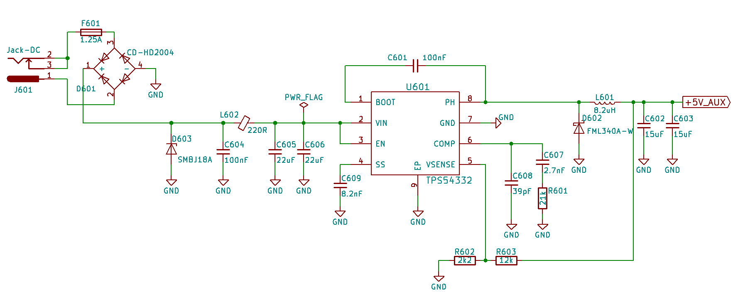

Figure 21: Auxilary power schematic

#### Battery input

This circuit protects the Li-Ion or Li-Po battery from undervoltage, overvoltage and overcurrent. It also protects the circuit against reverse voltage.

The AP9101C keeps a constant eye on the voltage across the battery terminals, comparing it to an internal threshold.

To protect against overcurrent, the voltage across the mosfets is measured. This voltage, present on VM, is then compared against an internal threshold. The maximum current depends on the on resistance of the mosfets.

If either of these thresholds are exceeded, the mosfets are shut down, preventing current from flowing.

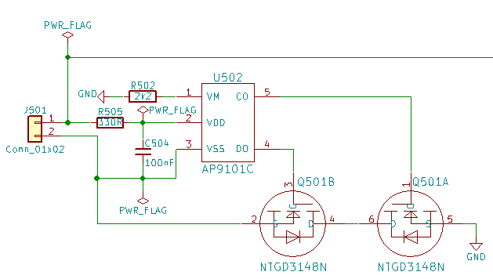

Figure 22: Battery input schematic

#### Battery charging

The DIO5158 has been chosen to support battery charging. It is configured to charge the battery at 812 mA from either the USB or Auxiliary power input. As the battery should last at least 2 hours, making for a minimum battery capacity of 2600mAh, temperature of the battery while charging isn’t really a concern. The temperature protection is therefor just fed by a voltage divider.

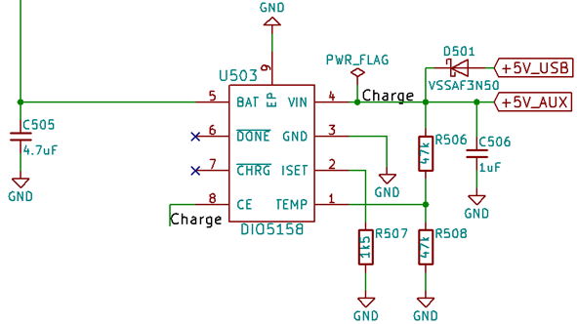

Figure 23: Battery charging schematic

#### Battery boost

The circuit shown below boosts the battery voltage up to 5V with a limited current of 1.5 A. The PAM2401’s relatively low quiescent current and high efficiency decrease wasted battery capacity.

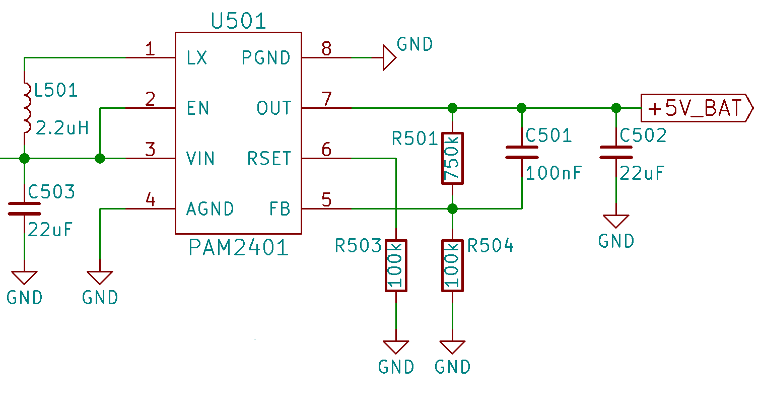

Figure 24: Battery boost schematic

#### Digital supply

This buck converter which is the same as the digital supply found on the compute board, is fed from the power switch output of the compute board. As with the digital supply on the compute board, it outputs 3.3 V and powers the ESP32 and is used for the switches and rotary encoders.

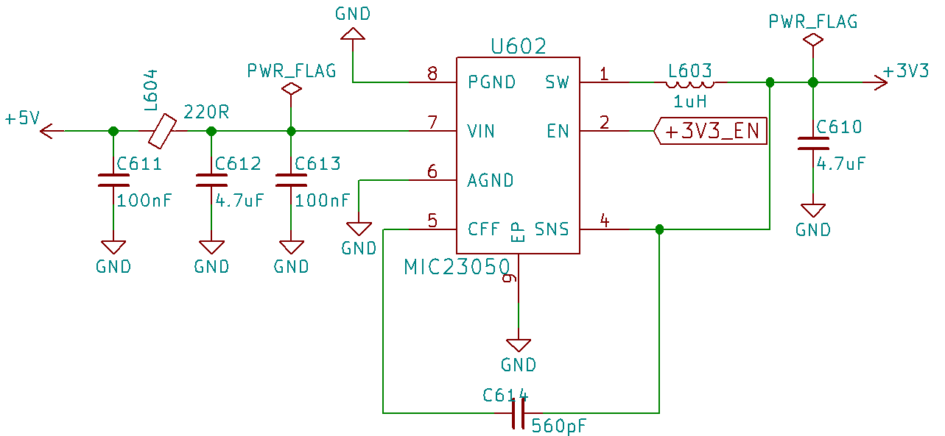

Figure 25: Digital supply schematics

#### Biasing

Biasing is putting a signal at a predetermined voltage. In our application, this is used for the floating inputs. A voltage buffer provides the reference for inputs. The reference’s voltage is the same as the center voltage of the CODEC. This is necessary because the supply for the preamps and CODEC are single ended. Although not completely necessary, the same has been done for the outputs. The supply for the op-amp is filtered through a 10 resistor and a 22 µF capacitor. This low-pass filter has a cut-off frequency of 4.5 kHz.

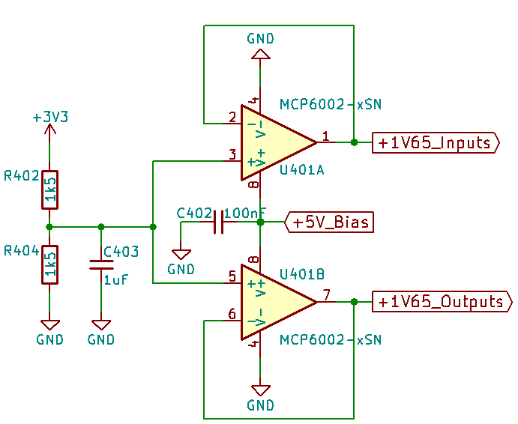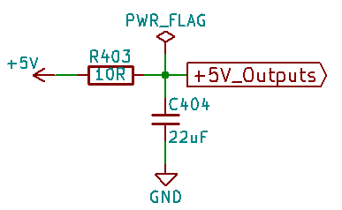

Figure 26: Biasing circuit

#### Phantom power

In order to keep cost low and reuse an IC, the TPS61170 boost converter was chosen again, this time generating 48 V for the phantom power used by condenser microphones.

Seeing that the TPS61170’s maximum output voltage is only 38 V, a voltage doubler was added. D401 and C411 make up the first part of the boost converter. They generate a 24 V. This will provide an offset to the bottom end of C410. This point now contains the peak voltage from the inductor and the 24 V offset. Passing that through diode D403 and smoothing it out provides us with 48 V.

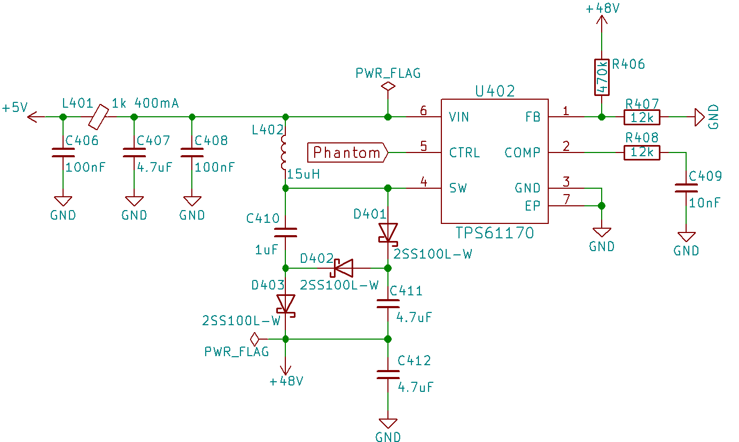

Figure 27: Phantom power schematic

Phantom power can be enabled for each input individually. This is realized using a complementary pair of transistors in a high-side switch configuration. The high value resistors used are chosen to limit the amount of current through the phantom power resistors in a short circuit event.

To reduce noise coming from the phantom power, the 6.81 k resistors used have to be matched within 0.1 % of each other. This will make it easier on the common mode rejection which reduces the noise from the phantom power.

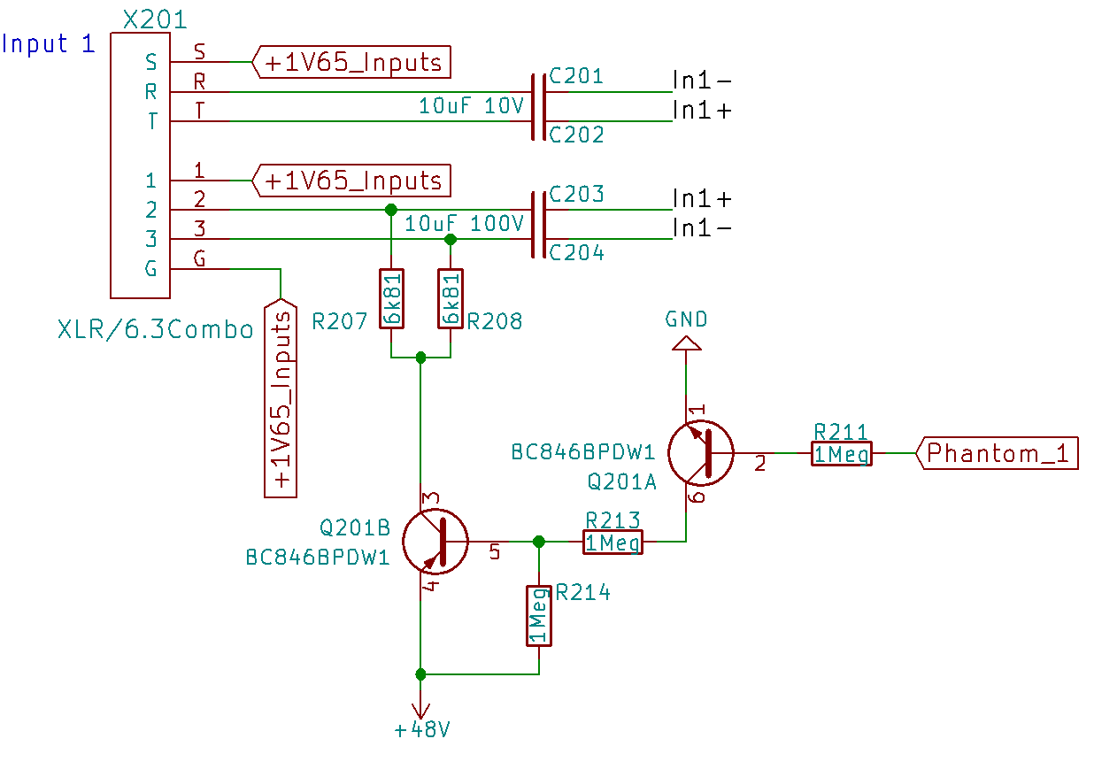

Figure 28: Input schematic

### Pre-amp

Before the signal reaches the pre-amp, it is coupled through the aforementioned  
bi-polar electrolytics. As seen in the figure above, each input has its own pair of input capacitors. This is to block the 48 V phantom power from coming on the 6.3 mm jack part of the compo input connector.

After being coupled, a fixed 1 Meg impedance is introduced, together with a switchable 1.5 k impedance. The purpose of these is to load the input source. The 1 Meg is a standard load for guitar, bass and various other instruments. 1.5 k is the normally used impedance to load down microphones.

The loaded signals then go through a 100k resistor, after which a switchable 47k is present. This forms a pad which, when turned on, attenuates the input by about -15 dB, depending on the source impedance.

As the goal is to support both guitar and a large variety of microphones, including dynamic ones, which can have outputs as little as 1 mV, a gain ranging from 1 V/V, otherwise known as unity gain, up to 1000 V/V is supported. With the audio bandwidth being up to 20 kHz, a minimum gain-bandwidth of 20 MHz is needed.

This considered, the MCP634 op-amp with its low noise and low distortion is chosen. Its minimum common-mode rejection ratio of 66 dB combined with that of the CODEC, 82 dB provide good noise rejection. This allows for long differential cables leading up to the input connectors without decreasing noise performance.

As seen in the figure below, the op-amp configuration used is that of an instrumentation amplifier. This configuration allows for a single-gang potentiometer to be used, minimizing gain mismatches. Its differential output also gives better THD+N at the CODEC side.

After going through a low-pass filter with a cut-off frequency of 23 kHz, it is kept between absolute maximum ratings for the CODEC using 2 back to back zeners. This can also be found right before the op-amp inputs, protecting them from unreasonable voltages.

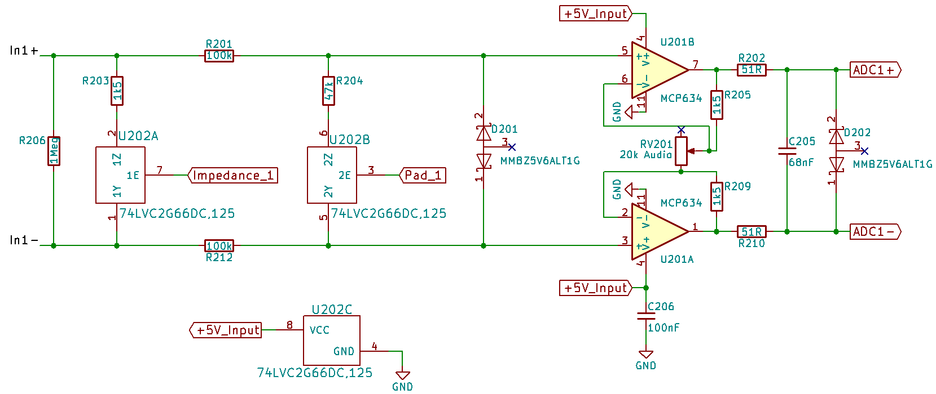

Figure 29: Pre-amp schematic

### Auxiliary input

In order to play to music, a 3.5 mm stereo input jack is present. This can take signals from a phone or computer over an aux cord. The input is coupled and passed through a 23 kHz low pass filter. To protect the CODEC from overvoltage, a zener is fitted on each channel.

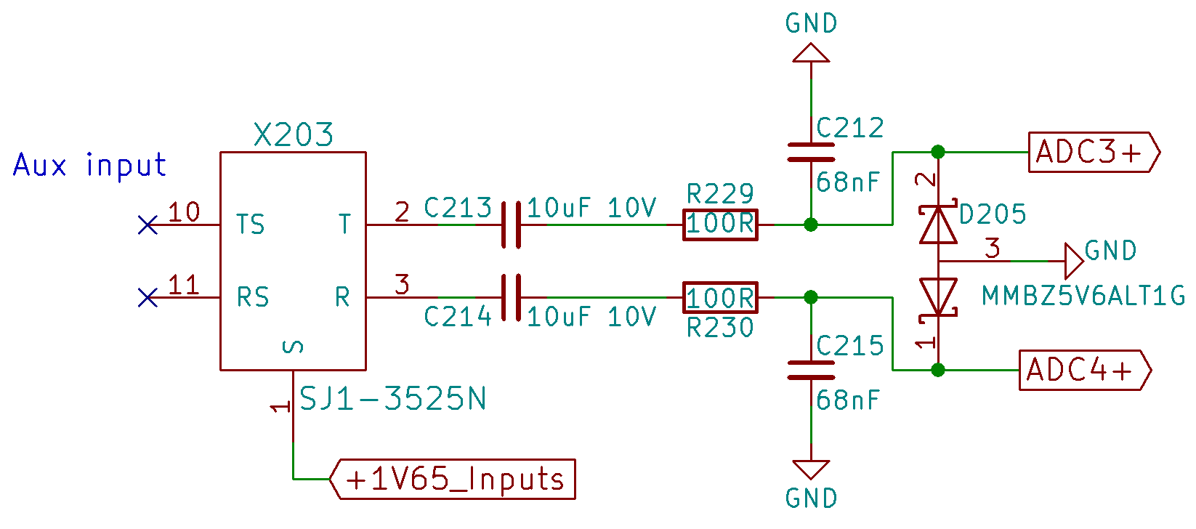

Figure 30: Auxiliary input schematic

### Output

The main output is a 6.3 mm TRS jack. This sort of output supports both singled-ended and differential. The ring may be shorted to the sleeve.

Starting at the left of the schematic, the differential DAC output goes through a low-pass filter, reducing noise above 23 kHz. It is then passed through an op-amp configured as a voltage follower or buffer. The outputs are then protected by back to back zeners, protecting from outside voltage sources exceeding 3.3 V. The output is then pass through high voltage bi-polar coupling caps into the output. These capacitors allow for phantom power being put on the output. This could occur when an XLR to TRS cable is used.

The op-amp used here, the TLV9064 was chosen because of its known THD+N figure.

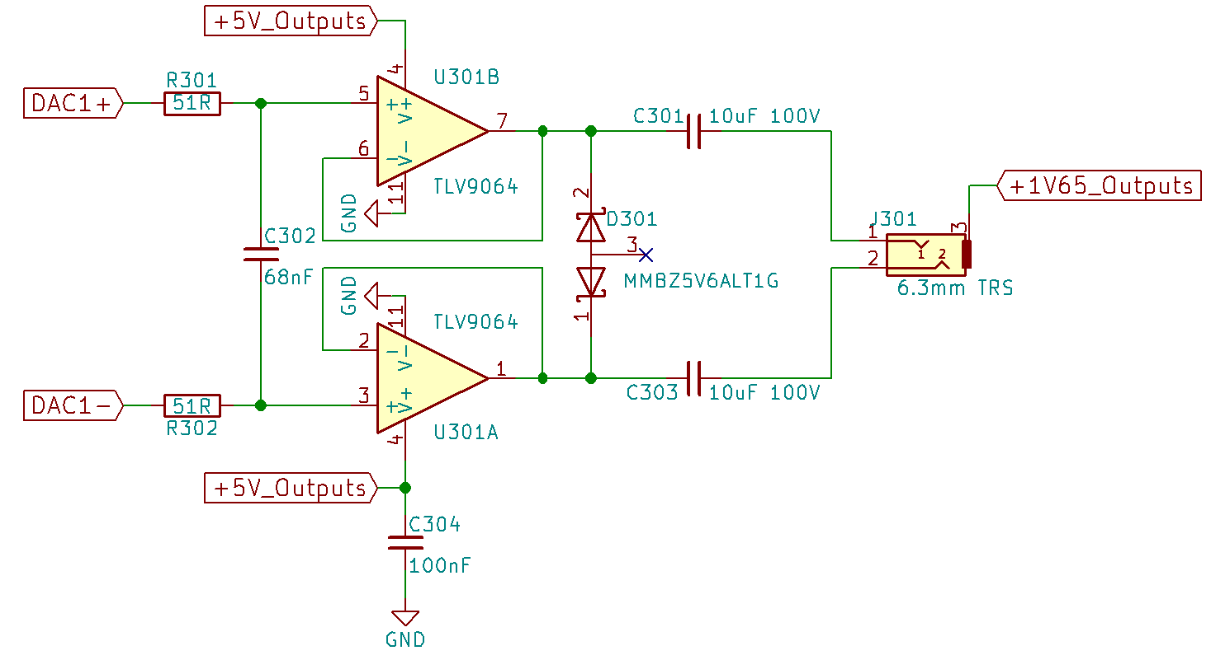

Figure 31: Output schematic

### Headphone output

This output has a 3.5 mm jack. It allows connecting headphones or external speakers. This circuit is almost identical to the main output one. It’s different in that the outputs are single-ended, making for a stereo output. This time, the dual channel zeners are connected as one zener per channel. Smaller, less expensive output capacitors with a lower voltage rating have also been used as the chances of large DC voltages appearing on this output significantly smaller.

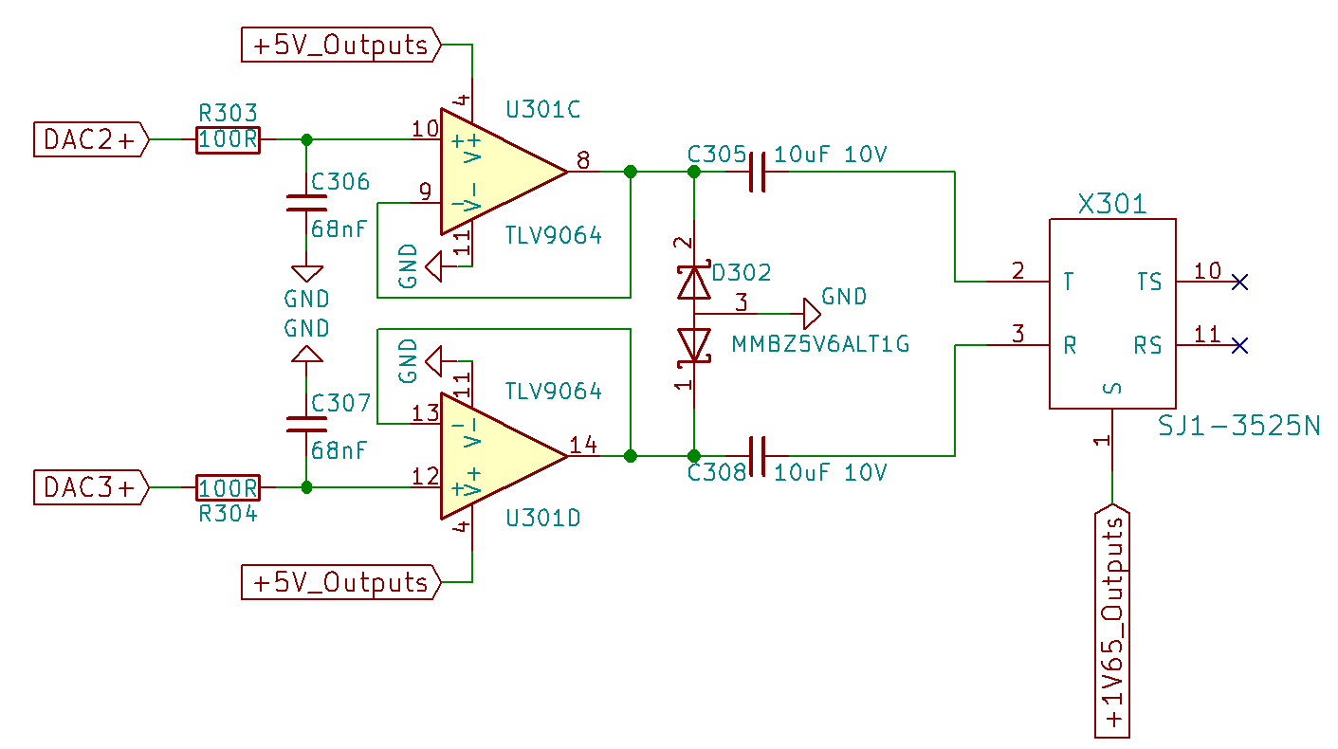

Figure 32: Headphone output schematic

### Rotary encoders and switches

For rotary encoders, the Bourns PEL12D-4225S-S1024 was picked out. This rather expensive encoder features a bi-color LED and a switch. These LEDs are used as status LEDs of the different channels.

The E-Switch PS1024A is the switch used for toggling effects. This switch isn’t as fancy as the rotary encoder.

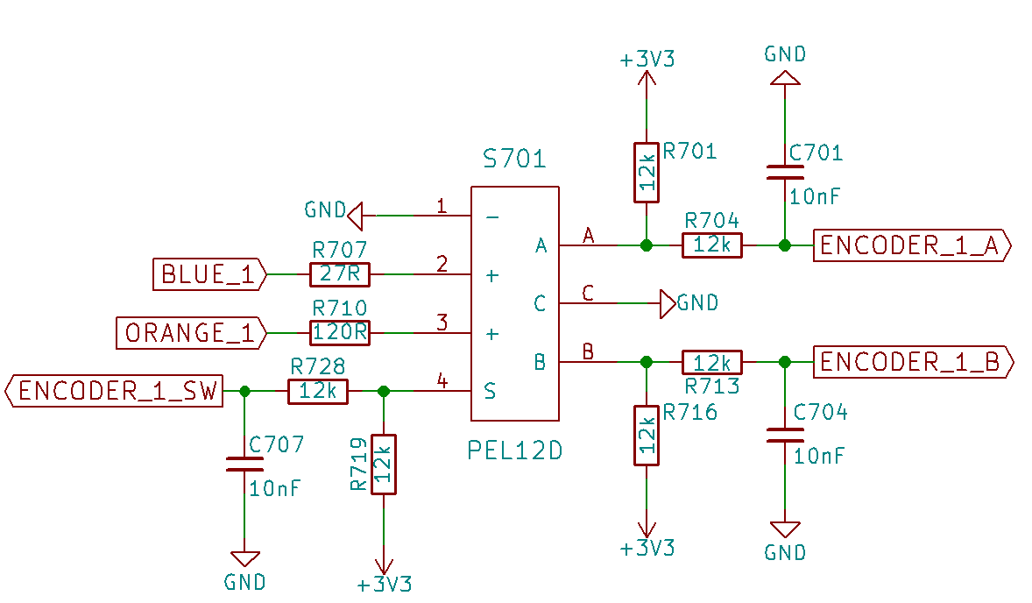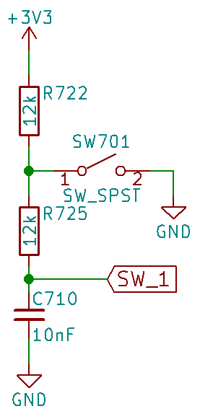

Figure 33: Rotary encoders and switches schematic

All outputs are hardware debounced. Meaning that they pass through a low-pass filter. This is necessary because when a button is pressed, the state is instable for a while. Debouncing in hardware makes it easier on software development.

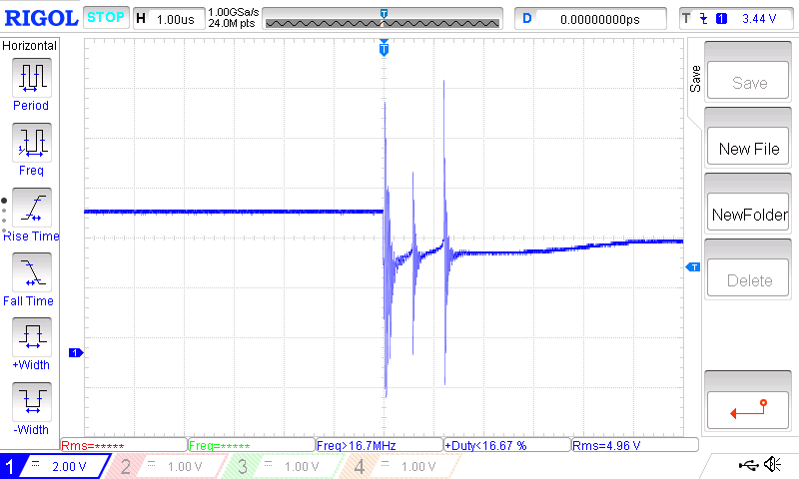

Figure 34: Bouncing example

### ESP32

Either an ESP32 development board or the SMD ESP32S can be mounted on the board. Its Wi-Fi gives the ability to make web applications to control the effects pedal. The ESP has been given the necessary buttons and header for programming.

The ESP32 controls the rotary encoders’ LEDs and is also used to enable or disable phantom power and its individual channels.

Communication between the STM32H7 and the ESP is established over the UART interface.

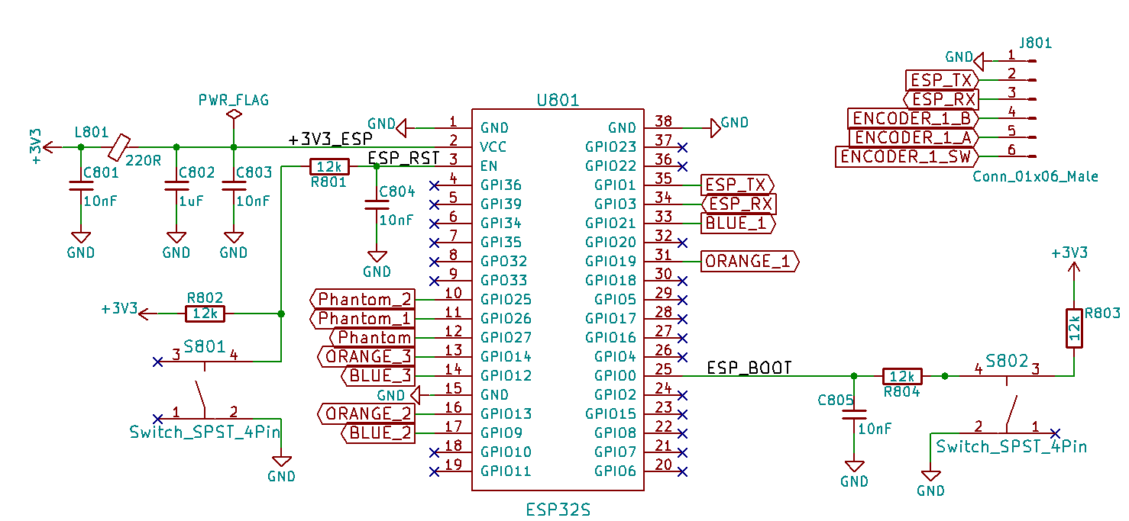

Figure 35: ESP32 schematic

## Design

The switches and audio connectors double as a solution to mount the boards to an enclosure. The switches lift themselves up to the topside of the case using a nut. The audio connectors provide support by protruding through the rear wall of the case.

The LCD is held in place by 4 standoffs, a custom bracket and double sided tape or glue. The bracket and the I/O PCB are held in place using 10 mm standoffs and M3 screws. The double sided tape or glue can then be applied to the bracket to which the LCD then attaches to.

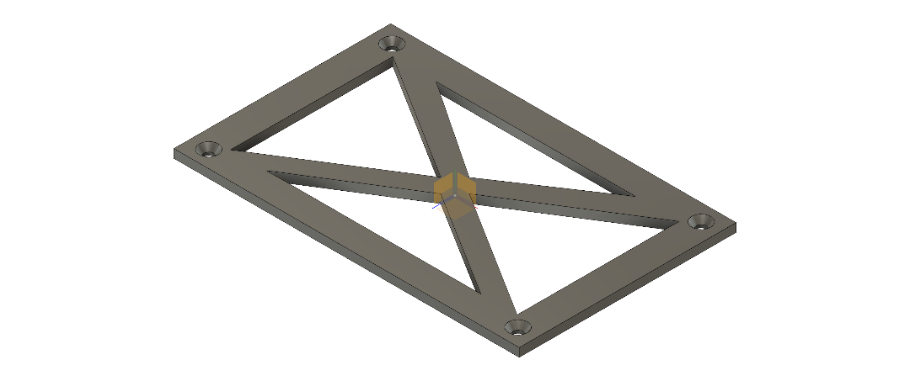

Figure 36: LCD mounting bracket

# Software

This segment goes over the programming of the STM32H7 and its peripherals.

## Flexible Memory Controller

The FMC is a peripheral which can be configured to communicate with a variety of memory devices. SRAM[18], PSRAM[19], SDRAM[20] and NOR and NAND flash are all supported. On this board, the FMC is used to talk to the 32 Mbytes of SDRAM.

### Configuration

Following figures show the configuration of the FMC according to the SDRAM timing specifications.

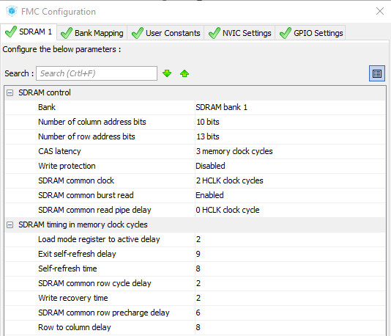 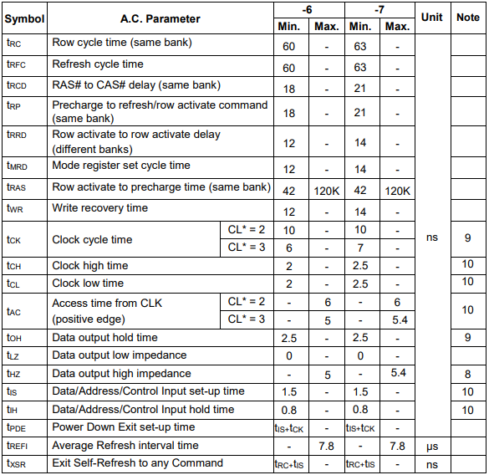

Figure 37: FMC configuration

The FMC is given a 200 MHz clock, resulting in a 100 MHz communication to the SDRAM. This makes the configuration a little slower as configuration was done with 7 ns clock time in mind. However, this shouldn’t affect communication, instead making it more reliable, staying well within spec.

### Initialization

Initialization steps for the SDRAM are adopted from the STM32F7 discovery’s board support package. These steps configure the FMC’s SDRAM command mode register and set the refresh rate in the timing register. These steps can also be found on page 800 of the STM32H7’s reference manual.

### Data transfer

After initialization, the SDRAM can be accessed using the HAL_SDRAM commands. The HAL_SDRAM_Read_8b and HAL_SDRAM_Write_8b can be used to transfer 8-bit arrays in blocking mode, meaning that it won’t continue until the transfer is finished. Other data sizes can also be transferred using the _16b or _32b functions.

Data can also be transferred using the MDMA controller by calling HAL_SDRAM_Read_DMA or HAL_SDRAM_Write_DMA. This won’t take as much resources from the CPU. The variable has to be located in the D1 or TCM section of the internal RAM for the MDMA to be able to access the variable.

## SPI

The SPI bus is used to configure the CS42448 CODEC.

### Configuration

Following figures show the configuration of the SPI5 peripheral according to the CODEC’s timing specifications.

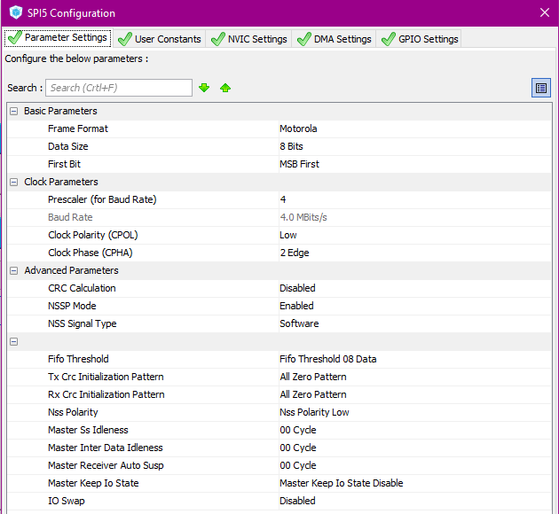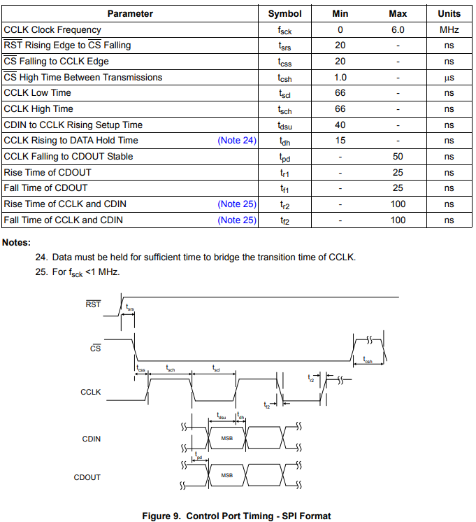

Figure 38: SPI configuration

As settings won’t be changing constantly, this is just done in blocking mode.

### CODEC initialization

After power-up, the fixed chip address is send followed by a logical 0, indicating that a write action is going to occur. Next, the memory address pointer is send. This contains the address to the register which is going to be written. It also has an bit which, when high, increments the memory address pointer. Doing this allows multiple settings to be adjusted without having to resend the chip and memory address.

In this initialization ADCs and DACs are configured, the protocol to the STM32H7’s Serial Audio Interface is set up and transition settings for volume changes are specified.

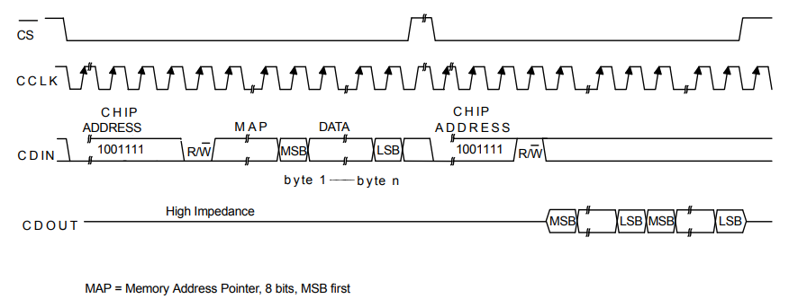

Figure 39: SPI communication

## SAI

The Serial Audio Interface is a peripheral which can be configured to match many audio type protocols. Examples of such protocols are I2S, PCM, AC’97 and many more. The SAI is used to communicated with the CS42448 CODEC.

### Configuration

The next figures show the SAI being configured in Time Division Multiplexing mode.

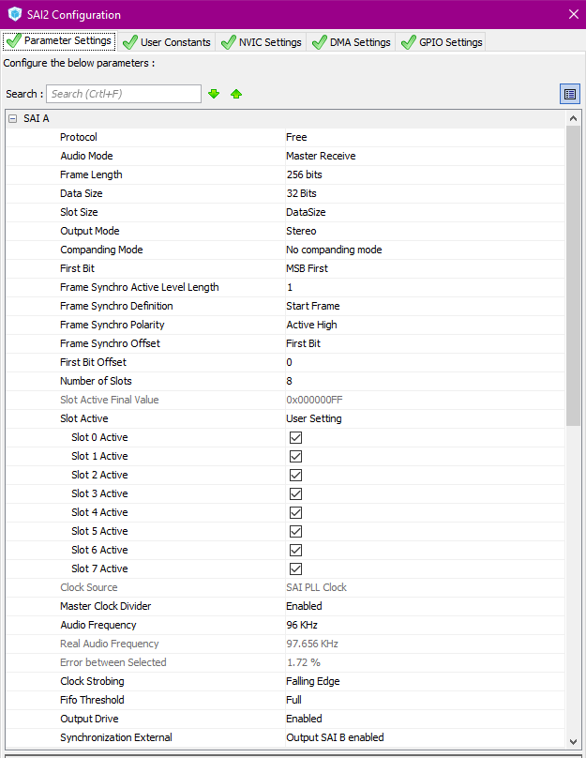 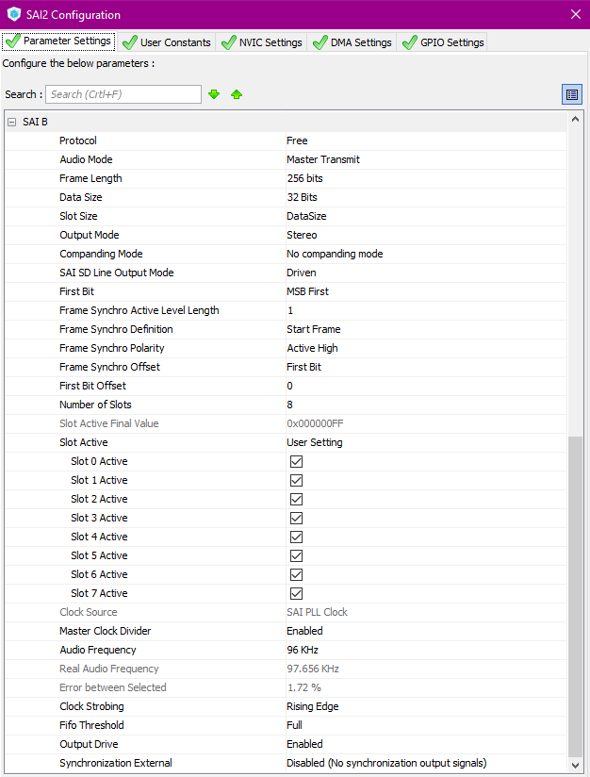

Figure 40: SAI configuration

This mode send all data over 2 channels. One for the ADCs and one for the DACs. Each channel has a frame select line, a clock line and a data in or output line. The frame select line, LRCK in the figure below, indicates the start for the next 8 data words. These data words, send over the data in or output lines, correspond to the analog in- and outputs.

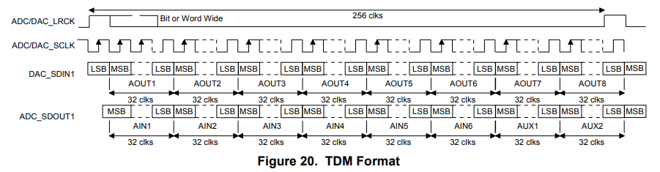

Figure 41: TDM format

### Utilization

As the CODEC provides a constant data stream, it makes sense to use the SAI with DMA enabled. The Direct Memory Access peripheral copies data from the SAI’s buffer to a variable without using the STM32H7’s core. Because of segmented memory, the variable must lie in the same domain as the DMA’s domain, D2. In this domain, 288 Kbyte of RAM is available.

Before using the DMA, it must be enabled and configured. It’s set up for the DMA’s data width matches that of the SAI. The circular mode allows for old data to be overwritten. The DMA’s 4 word fifo can also be enabled to reduce traffic over the DMA. This is accomplished by buffering a maximum of 4 words before it is written to the memory.

Figure 42: Without DMA

Figure 43: With DMA

The left figure shows the CPU having to show the transaction between the peripheral and the memory after which the CPU can use the data from memory.

The figure on the right illustrates using a peripheral using DMA. It shows the reduction of CPU usage, making more time for data processing.

To start the process, channel B of the SAI must be enabled. This enables the master clock output which is used by the CODEC as a clock sources for its converts and digital filters.

After this, HAL_SAI_Receive_DMA followed by HAL_SAI_Transmit_DMA can be called. These functions take the peripheral, data pointer and data size as parameters.

To increase performance, the data size should be more than just one data frame. Processing just one would make processing the digitalized audio very hard on the core. Using blocks of data gives more time for the processing. This however, does increase input lag. As a starting point, using a block of 24 samples, corresponding to 250 µs at the CODEC’s sampling frequency of 96 kHz, is used. The 24 sample block makes the output lag half a millisecond behind the input, which is tolerable in this application.

This lag comes from the 250 µs sampling time plus the maximum 250 µs of editing time before the data will be send to the analog output. At the core frequency of 400 MHz, the editing time corresponds to 100 000 clock pulses.

As the block size is a variable, it can always be adjusted depending on the necessity of extra clock cycles needed to complete editing the waveform. Wanting to adjust this while running will make the structure of the program more complex. A solution where the user can adjust this depending on their preference could also be implemented.

## Program structure

### Startup and audio

Figure 44: Startup and audio flowchart

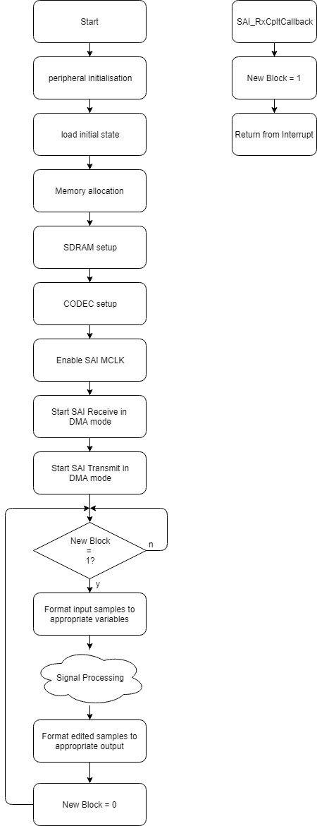At startup, the peripherals get initialized and the system is put into a predefined state.

Next up, input and output block memory and memory for the individual channels gets allocated. Note that they have to be allocated in the right domain when DMA is used.

Following that is the SDRAM and CODEC setup as explained in paragraph 2.1 and 2.2.

Having done all setup, the master clock can be provided to the CODEC and audio in and output can start.

From here on out, the while loop has started. Every time a new set of samples is available, they will be formatted and put in the right variable specific to their channel.

The individual audio streams can then be processed according to user specification.

After processing, the stream is put back into its original format and are written to the output variable.

The new block indicator is reset so that the samples don’t get reprocessed.

# Conclusion

With some refinement, this device can be a great platform for both audio and programming enthusiasts.

## Compute board

The compute board shows great potential for use in other projects. It is compact while still packing a lot of performance.

### Possibilities for improvement

Is this board is built to be reusable in other projects, it would have been nice if it was shorter than 80mm. This could provide lower cost as an application board could be 100mm long, staying within cheap PCB manufacturing size.

The power multiplexer on this board , while nice, does increase cost and complexity.  
Even though it does reusability, it would make more sense to have this fitted on the application board.

Right now the current going through the power pins of the Mini PCI-e connector are passing double its maximum rating. To stay within its safe rated spec, some I/O pins will have to be traded in for safe operating conditions.

The touch panel connector footprint, while solderable, should be adjusted for a better fit.

### Flaws

All peripherals which were necessary for this thesis have been tested. This showed an error in the LCD connector where signals were mirrored. Another error in the PCB is the SD card being back to front.

Removing card detection support via a switch, the SD card problem could be solved by simply getting a different card holder such as the HRS DM3AT.

Addressing the LCD connector is a bit harder. If not touchscreen is required, the connector can be installed backwards. For this thesis, this solution is only good for debugging purposes as the display won’t be mountable in a case. A temporary solution for touchscreens could be making a PCB which mirrors the signals. The signals can then be pass to this PCB via a short flat flex cable going up to a connector. The screen will also be connected to this PCB.

The tall programming connector used to program the STM32H7 prohibits assembly in a case with the LCD installed.

For long term solutions however, it seems wise to reroute the board.

## I/O board

The I/O board serves as a good companion to the compute board. Noise in the preamps is practically nonexistent.

### Possibilities for improvement

Some slightly taller switches would make for an easier fit in a case.

Controlling the gain via the potentiometer happens in a very non-linear fashion. Although precaution had been taken by the use of logarithmic potentiometers, this could still be better. Lower value potentiometers could be chosen to lessen this problem.

### Flaws

The battery connector’s footprint is wrong. Its holes should be spaced further apart.

The footprint for the 6.81 k phantom power resistors is too small.

## Software

The software is at a point where the general structure is present. More specifically, audio is coming in, made ready for processing and processed audio going back out.

No effects have been written so far.

# List of figures

Figure 1: Compute board front and back 7

Figure 2: I/O board front and back 8

Figure 3: In- and output connectors 8

Figure 4: I/O board with the compute board plugged-in 9

Figure 5: Compute board block diagram 10

Figure 6: Power MUX schematic 12

Figure 7: Power MUX flowchart 12

Figure 8: Digital supply schematic 13

Figure 9: Analog supply schematic 13

Figure 10: Backlight supply schematic 14

Figure 11: MCU 15

Figure 12: RAM 15

Figure 13: CS42448 block diagram 16

Figure 14: SD card pinout 17

Figure 15: Ringing simulation 18

Figure 16: MCU decoupling 19

Figure 17: Length matching example 19

Figure 18: Connectors 21

Figure 19: I/O board 21

Figure 20: I/O board routing 22

Figure 21: Auxilary power schematic 25

Figure 22: Battery input schematic 26

Figure 23: Battery charging schematic 27

Figure 24: Battery boost schematic 27

Figure 25: Digital supply schematics 28

Figure 26: Biasing circuit 28

Figure 27: Phantom power schematic 29

Figure 28: Input schematic 30

Figure 29: Pre-amp schematic 31

Figure 30: Auxiliary input schematic 31

Figure 31: Output schematic 32

Figure 32: Headphone output schematic 33

Figure 33: Rotary encoders and switches schematic 33

Figure 34: Bouncing example 34

Figure 35: ESP32 schematic 34

Figure 36: LCD mounting bracket 35

Figure 37: FMC configuration 36

Figure 38: SPI configuration 37

Figure 39: SPI communication 37

Figure 40: SAI configuration 38

Figure 41: TDM format 38

Figure 42: Without DMA 39

Figure 43: With DMA 39

Figure 44: Startup and audio flowchart 40

# List of acronyms

1. Analog to Digital Converters
2. Digital to Analog Converters
3. Low Dropout Regulator
4. Sample frequency divided by two
5. Pulse Width Modulation
6. Floating Point Unit
7. Serial Peripheral Interface
8. Inter-Integrated Circuit
9. Universal Asynchronous Receiver-Transmitter
10. Total Harmonic Distortion + Noise
11. Flexible Flat Cable
12. Circuitry required to implement physical layer functions
13. UTMI+ Low Pin Interface
14. On The Go
15. Electromagnetic Interference
16. Electrostatic Discharge
17. Transient Voltage Suppressor
18. Static Random-Access Memory
19. Pseudo Static RAM
20. Synchronous Dynamic RAM

# List of citations

Figure 13, 38, 39 & 41: <http://www.mouser.com/ds/2/76/CS42448_F4-275685.pdf>

Figure 37: <https://www.mouser.de/datasheet/2/12/AllianceMemory_256M_AS4C32M8SA-6TIN-7TCN_June2017v-1288453.pdf>

# Attachements

1. Analog to Digital Converters
2. Digital to Analog Converters
3. Low Dropout Regulator
4. Sample frequency divided by two
5. Pulse Width Modulation
6. Floating Point Unit
7. Serial Peripheral Interface
8. Inter-Integrated Circuit
9. Universal Asynchronous Receiver-Transmitter
10. Total Harmonic Distortion + Noise
11. Flexible Flat Cable
12. Circuitry required to implement physical layer functions
13. UTMI+ Low Pin Interface
14. On The Go
15. Electromagnetic Interference
16. Electrostatic Discharge
17. Transient Voltage Suppressor
18. Static Random-Access Memory
19. Pseudo Static RAM
20. Synchronous Dynamic RAM